Carbon Cycling:
Environmental Processes that Change Our World

High School

TEACHER GUIDE

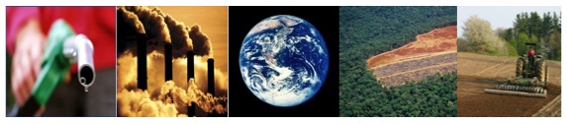

Lindsey Mohan, Jonathon Schramm, Hui Jin, Li Zhan, & Andy Anderson
Environmental Literacy Project
Michigan State University
November 2009
Outline of Activities

Unit Overview 3
Embedded Assessments 4
Materials List 5
CORE ACTIVITIES 7
Activity 1: Scaling up - carbon in organisms & ecosystems 7
Activity 2: Describing the Carbon Cycle 13
Activity 3: What Do Food Chains Tell Us? 16
Activity 4: Biomass and Energy Pyramids 23
Activity 5: Putting It All Together (Carbon Reservoirs) 29
Activity 6: Plants As a carbon Reservoir 36
ACTIVITY 7: Soil as a carbon reservoir 42
Optional inquiry activities 47
Activity 8: How are Plants Unique? 47
Activity 9: What Happens to dead plants and animals? 53
Activity 10: Measuring Soil Respiration (2 DAYS) 58
optional Account-Building activity 62
Activity 11: Organisms Give Off Carbon Dioxide 62
OPtional citizenship activity 66
Activity 12: Bio- and fossil fuels – what’s the difference? 66
APPENDIX A: BACKGROUND FOR TEACHERS 69
APPENDIX B: TOOLS 70
Simplified Spicebush Food Chain 70
Macroscopic Carbon Cycle Diagram 71
Landscape Scale Carbon Cycle Diagram 72
complete carbon cycle diagram 73
Scale 74
Powers of Ten 74
Matter and Energy 75
Matter and Energy Process Tool 75

Unit Overview

Along with other Environmental Literacy materials, this unit helps students use the principles of SCALE, MATTER, and ENERGY in thinking about biological systems, and introduces students to several tools that support reasoning with these principles. This unit focuses in particular on helping students see patterns in those processes that influence the relative amounts of atmospheric CO₂ and organic carbon molecules in the carbon cycle.

Core Activities

Activity 1: begins with macroscopic events that students are familiar with: these are the gas-gas cycles they commonly use to explain the way organisms and objects change air around them. The lesson directs students to consider where the carbon in CO₂ comes from in respiration by all organisms. This material overlaps somewhat with that in other units and may be shortened or skipped as appropriate for your students.

Activity 2: introduces the idea of landscape-scale nutrient cycles, such as that for carbon. Students work through the concept that carbon exists in a large variety of organic molecules (including fossil fuels) and relatively few inorganic ones (in the atmosphere, chiefly CO₂), and identify the very few processes (combustion, respiration, photosynthesis) that move carbon between various pools.

Activity 3: students use the process tool to construct simple food chains involving plants and animals. In Activity 4, students use this information to engage in a simple energy/biomass pyramid game. Both activities help students see that organisms in a food chain give off CO₂ and transform chemical energy into heat and motion energy, thus making chemical energy less available to the next trophic level.

The final three activities—5, 6, 7—take the unit to the large scale, thinking about different organisms as “carbon reservoirs” and how those carbon reservoirs are related to fluxes in carbon. Students consider how carbon moves between key reservoirs—the atmosphere, biosphere, and fossil fuels. They also engage in two activities, which have them brainstorm how different types of plants and soil do or do not sequester carbon, and how human actions may influence that process.

Inquiry Activities

Activity 8: Explores the role of plants as the primary organisms on our planet that move carbon in the form of CO₂ from the atmosphere into organic molecules that contain chemical energy. Students conduct a lab that show plants take in CO₂ and they use the process tool to show how plants change matter and energy. They then think about the unique role plants play in the carbon cycle. This may be a useful review of photosynthesis, and would likely work best between core activities 2 & 3.

Activity 9: Includes a lab that must be started in advance in order to observe mass changes during decomposition. Students observe that decomposers give off CO₂ and H₂O and that mass changes over time during decomposition. They use this information to complete the process tool. Would work best after core activity 4.

Activity 10: Centers around a lab that allows students to explore hypotheses related to soil carbon sequestration and respiration (i.e.-decomposition of plant material in soil). The lab requires either two days, with the first built around set-up and the second focused on collecting data, or one day with substantial teacher set-up in advance to prepare the sampling units. Most effective after core activity 7.

Account-Building Activity

Activity 11: concentrates on the idea that all organisms, including plants and animals, give off CO₂. The teacher demonstrates this by blowing into a beaker of BTB indicator to show that people give off CO₂. This sparks discussion of where the “C” that we breathe out comes from. Furthermore, students engage in exercises that illustrate macroscopic indicators of changing matter and energy (i.e., sweat, warmth, breathing hard, etc). They use these observations to complete the process tools for both animals and plants. This would work well in conjunction with inquiry activity 8, between core activities 2 & 3.

Citizenship Activity

Activity 12: allows students to explore the difference between bio- and fossil fuels in light of their understanding of the carbon cycle, particularly with regards to the large differences in time scale for the two types. This activity is intended to provide links to an important current issue related to the carbon cycle; activities in the Human Energy Systems unit will provide many other explorations of this issue. This activity is probably best done at the completion of the unit, since it summarizes threads from many other activities.
Embedded Assessments

Make copies for the Environmental Literacy Project (for focus students only)
- Carbon Movements
- The Carbon Cycle
- What do Food Chains Tell Us?
- Island Ecosystem
- Where is Carbon Dioxide Going?
- Plants and Global Carbon Cycling
- Soil and Global Carbon Cycling
- How are plants different?(if used)
- Organisms Give Off Carbon Dioxide (if used)
- Decomposition Questions (if used)
- Tracing the Carbon (if used)

Materials List

Teaching Materials
Overhead or opaque projectors
Blank overheads to record student ideas & Vis-à-vis markers
Process tool: Plant growth & use, animal growth, animal movement, decomposition, food chains
Powers of Ten poster
Optional: Internet access and LCD projector for displaying helpful visuals

Student Handouts
Carbon Movements
The Carbon Cycle
What do Food Chains Tell Us?
Island Ecosystem
Where is Carbon Dioxide Going?
Plants and Global Carbon Cycling
Soil and Global Carbon Cycling
How Are Plants Different? (optional)
Organisms Give Off Carbon Dioxide (optional)
Decomposition Questions (optional)
Tracing the Carbon (if used)

Lab Materials/Equipment
Plant lab (per group)
2-4 sprigs Elodea
2 test tubes with cap or glass jar with lid
250-mL Erlenmeyer flask
1 Straw
.04% solution of BTB
60-watt lamp & bulb or grow light
Breathing BTB demonstration
BTB solution
100-mL Beaker or other clear container
Straw
Decomposer Lab (per class)
Rotting materials (compost or apple)
Digital balance
Cup or other container
Sealed container
BTB
Test tubes (connected to each other with stoppers, tubes)
***some materials may be optional depending on the chosen lab

Other Materials
Plant Sequestration Demo (real materials or photos)
- One example each of: annual plant (possibly corn or other crop plant), perennial plant (turf grass), herbaceous plant (dandelion), woody plant (tree or shrub), aquatic plant (sample of pond water), terrestrial plant (any potted plant).

Soil Sequestration Demo (real materials or photos)
- Samples of plant litter and soils from several habitats (forest, grassland/pasture, farm field); or use pictures if season is wrong for gathering samples
Organism Demo (real organisms or photos)
- Samples of organisms (woody plant [twigs from tree or shrub], herbaceous plant [tuft of grass], herbivore [insect like grasshopper], carnivore [mouse or small bird], mushroom [store-bought], bacteria [on agar plates]); or pictures to provide if season is wrong for gathering samples.

CORE ACTIVITIES

Activity 1: Scaling up - carbon in organisms & ecosystems

Overview
Carbon in and Between Organisms ~25 minutes
Carbon Movements: Process Tools ~25 minutes

TOTAL TIME: 50 minutes

Purpose

This series of lessons teaches students about carbon cycling processes in terrestrial ecosystems. It begins with material that the students are already familiar with: the simplified gas-gas exchange between plants and animals that students up into college still use to incorrectly discuss gas exchanges with organisms’ surroundings. By revisiting this representation, students will begin to tease apart two major transformations of carbon in living systems, that from inorganic form (CO₂) to organic via photosynthesis and that from organic back to inorganic in cell respiration. Students will use the matter and energy process tool to identify patterns in matter and energy movement between these two processes. The following lesson will then help them to take their observations to a larger scale, of ecosystems or even the globe. Robust understanding of these two processes is crucial for understanding the subsequent activities.

Materials
Student copies of Carbon Movements
Overhead or paper to record students’ questions

Advance Prep
Make copies and overheads if not supplied by MSU

Procedures
Optional Pre-assessment Questions
Note: More than the organism-level units, this unit relies on knowledge that students are likely to have encountered in other situations (such as the organism units). Particularly if you have not worked through those units with your students, you may want to use the pre-assessment questions for each activity to quickly gauge the level of understanding your students are beginning with. If desired to deepen their understanding, you may want to utilize one of the connecting activities (above) before beginning this lesson.
Photosynthesis: A small acorn grows into a large oak tree. Where does most of the weight of the oak tree come from? (Circle the best explanation from the list below).

A. From the natural growth of the tree
B. From carbon dioxide in the air and water in the soil
C. From water and nutrients that the tree absorbs through its roots
D. From sunlight that the tree uses for food.

Respiration: When leaves in a compost pile decay, they lose mass (and weight). What do you think happens to the materials that once made up the leaves? Choose the BEST answer from the list below.

a. The materials go away when the leaves decompose.
b. The materials change to heat energy.
c. The materials change into soil minerals.
d. The materials change into gases that go into the air.

Carbon in and Between Organisms ~25 min

In some form or another, almost all students have learned about gas exchange between organisms in terms of a carbon dioxide – oxygen cycle (see diagram below), where plants take in carbon dioxide and release oxygen, while animals do the opposite. While true in a broad sense, this type of understanding leaves students poorly prepared to understand carbon cycling in a significant way, and makes it difficult to see one of the fundamental truths of biology. Namely, that all cells (and organisms) must perform respiration at some point to maintain life. Living plants are also respiring at all points, but their net carbon flux is positive during the growing season (i.e.-more carbon absorbed). Ask students to work in groups of 2-3 students to analyze this oversimplified cycle in more detail (but do not visually display the cycle for fear of reinforcing the misconception). Is there anything that is incomplete or lacking in this description of living systems? Is it easy to imagine where the carbon is coming from or going to? Specifically, have them discuss the reactions within each type of organism (plants and animals) that are responsible for creating their inputs and outputs of matter (photosynthesis and respiration, respectively). Then ask them to consider whether these are the only processes that change gas concentrations around these types of organisms. Hopefully they will quickly realize that plants must also respire, and so must also intake some oxygen and release some carbon dioxide.

Carbon Movements ~25 min

Have students continuing working in their groups to complete the process tools on the Carbon Movements handout. If they have completed the relevant organism-level units in this or another class, they will likely be able to move through them quickly, but they are still valuable as review. After the groups are finished with the handout, have them share their reasoning with the rest of the class, and ensure that students see the distinctions between photosynthesis and respiration in terms of the ways in which they transform carbon.
Fig. 1: The Oxygen – Carbon Dioxide Cycle
= Misconception!
Risky to show students as may entrench thinking.

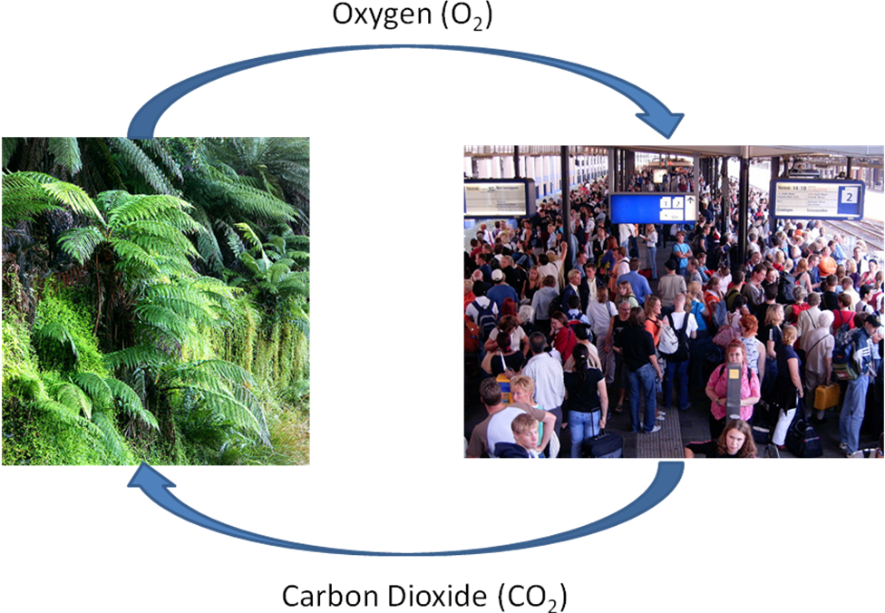

Name:____________________________________________Period/Hour:________

Carbon Movements

With your group, please fill out the following process tools to the rest of your ability.
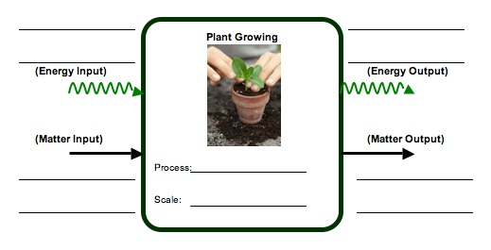
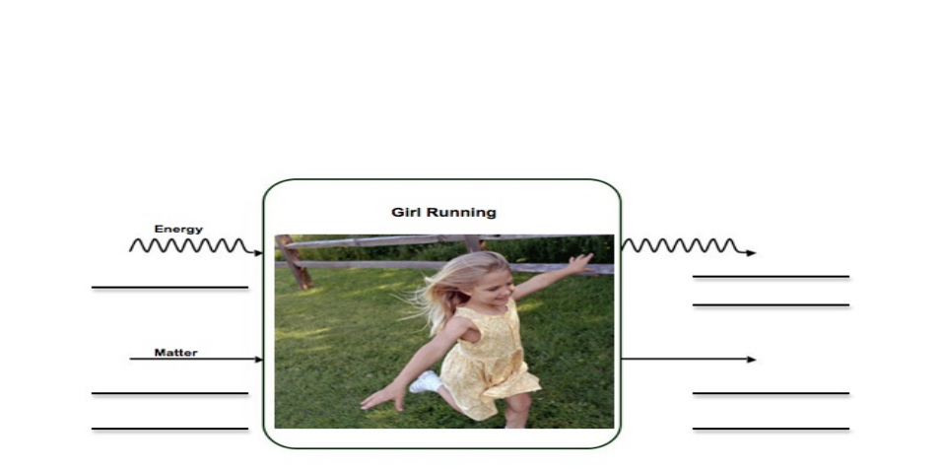
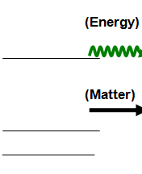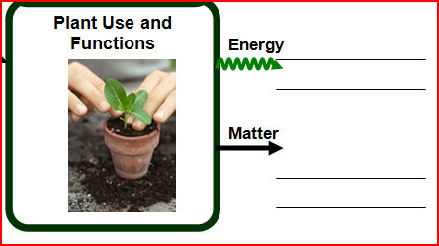
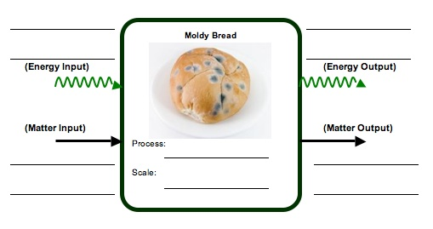

Questions

1) What similarities do you see between among these events in terms of emitting carbon?
__________________________________________________________________________________________________________________________________________________________________________________________________________________
How about in terms of taking up carbon?
______________________________________________________________________
____________________________________________________________________________________________________________________________________________

2) What are the main forms in which carbon occurs in the environment, based on your process tool discussion?

__________________________________________________________________________________________________________________________________________________________________________________________________________________

Activity 2: Describing the Carbon Cycle

Overview
Fluxes and Pools ~20 minutes
Forms and Movements of Carbon ~30 minutes

TOTAL TIME: 50 minutes

Purpose

This activity moves away from organism-level discussions of carbon pools and fluxes to begin discussing carbon cycling processes in terrestrial ecosystems. While this unit reviews metabolic processes that occur in individual organisms, such as photosynthesis and cellular respiration, the processes are situated in the context of large-scale systems. In this activity students are introduced to the concept of global nutrient cycles in general, and then given the opportunity to construct the carbon cycle based on their existing knowledge. In other words, the students will see that carbon cycling mainly involves finding out where carbon is located, in what form, and how it moves to other locations. Based on their responses to this activity, you may choose to use one or more of the optional activities on photosynthesis, respiration and decomposition.

Materials
Student copies of The Carbon Cycle
Overhead or paper to record students’ questions

Advance Prep
Make copies and overheads if not supplied by MSU

Procedures
Fluxes and Pools ~20 minutes
Begin by asking your students: Do materials cycle or flow in the earth’s ecosystems? Based on their previous knowledge, your students will likely agree that matter moves in cycles through ecosystems, although depending on the system, some matter is always coming in from elsewhere and leaving to elsewhere. At the scale of the whole globe, though, matter isessentially at a steady-state: what we have now is what we have had in the past and will have in the future. This is very different than the situation with energy, where the earth is always receiving new energy from the sun and losing it to space as infrared heat radiation (i.e.-energy flows). At any given moment, though, you can theoretically measure (or estimate) the amount of matter or energy in a given place, such as all of the trees in a forest, or the natural gas reserves of Texas. These places are termed “pools,” and the processes that move matter (and energy) between them are called “fluxes.” You’ll do more with these terms in part B of this activity.

Once your students agree on the cycling of matter in general, ask them if they expect that to be true for carbon in particular (hopefully yes!).

Forms and Movements of Carbon ~30 minutes
The O₂ – CO₂ cycle from activity 1 is incomplete because it treats animals and plants as different types of organisms without simultaneously stressing their fundamental similarity as carbon-based life forms. At this point, you’ll want to have students bring out their copies of the carbon cycle activity. Ask students which carbon “pools” they see on their diagrams, and in which molecular form they would expect to find the carbon occurring in each of those pools. Students should quickly identify wood/fossil fuels, detritus, detritivores, 1°/2° consumers, plants/algae/ cyanobacteria and the atmosphere as the pools, but they may have a little more difficulty identifying the forms of carbon. You can encourage them to keep their thinking broad at this point, since the actual variety of carbon-containing molecules in something like petroleum is huge, for instance. It would be sufficient to summarize the fossil fuel pool as containing hydrocarbons, the various living or recently-living organisms as containing “organic carbon,” and the atmosphere as containing predominantly carbon dioxide.

Note: the reading in exercise 10 of Systems and Scale (“Energy-Rich Materials”) could provide useful background material for your students if they haven’t encountered it yet.

Based on the forms of carbon discussion above, your students should quickly see that the pools of carbon in our simplified diagram can essentially be reduced to three broad types: fossil fuels, the atmosphere, and living/recently-living organisms. There are other significant pools, especially carbon in geologic form (limestone) and dissolved in the ocean as carbonic acid (H₂CO₃), but we will leave them out of the discussion for now. If your students seem very interested though, you could digress and work through the Complete Carbon Cycle diagram in Appendix B.

As a final step for this activity, have your students work together to fill in the blanks on their diagram that represent the flux processes. Remind them that these processes should be ones that can convert the carbon in one form or pool into carbon in the destination form or pool. In particular, you may want to discuss respiration in more detail: why do so many arrows pass through respiration? What do all of the source pools for respiration have in common?

After students have had a chance to discuss their thinking about the processes, bring them back together for a concluding discussion. Are they convinced that matter does indeed cycle? Are there other places where they could imagine carbon being moved to? The subsequent lessons will explore some of these fluxes and pools in more detail.

Name:____________________________________________Period/Hour:________

The Carbon Cycle
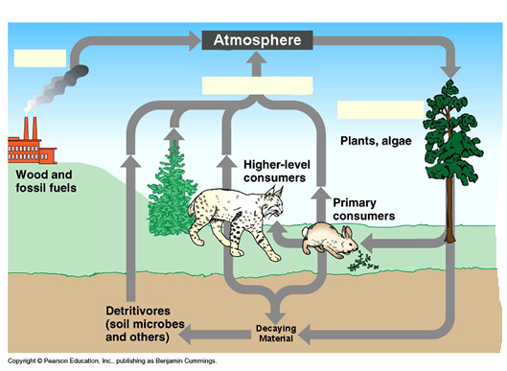
The diagram above shows parts of the global carbon cycle. In general, carbon in the earth’s systems is classified as either organic or inorganic, depending on whether it is in living or once-living materials (organic) or not (inorganic). Locations where carbon can be found are termed pools, and the processes that move carbon from one pool to another are called fluxes. Using the diagram, think of some specific pools where you might find organic and inorganic carbon molecules, as well as the types of molecules in which carbon might be found in those pools. Don’t worry as much about specific molecular names, unless you know some; instead try to identify categories of molecules. An example is provided. Complete the table below.

Organic Carbon |  | Inorganic Carbon
Plants | Molecule Types  Starch, Sugar |  | Molecule Types
Now fill in the three blank flux boxes with the process that would be responsible for moving carbon through each flux. Why does the middle flux have so many pools it moves carbon from?
____________________________________________________________________________________________________________________________________________________________________________________________________________________________________

Activity 3: What Do Food Chains Tell Us?

Overview
Introduction question ~5 minutes
What Do Food Chains Tell Us? ~30 minutes
Food Chains combined ~15 minutes

Total Estimated time: 50 minutes

Purpose
This activity continues our focus on movements of matter in the context of a familiar concept to most students: a food chain. A key idea about food chains that students often misunderstand is that both matter and energy are lost (as CO₂/H₂O and heat, respectively) as organisms higher up the chain consume those lower on the chain. This is due to the necessity of all organisms to undergo cell respiration to maintain themselves, resulting in less than 100% of their materials (and thus energy) being available to things that consume them. We’ll explore that inefficiency in more detail in activity 4, but in this activity be sure your students are grasping that some organic carbon is always transferred in trophic interactions, even as some is being released as CO₂ after respiration.

Materials
Overhead or Projected Copy of Simplified Spicebush Food Chain
Student copies of What Do Food Chains Tell Us?
Process Tool for Plant growth, Animal Growth, and Animal Movement

Procedures
Optional Pre-assessment:
An apple is eaten by a child and digested in his body.
a. What happens to the things in the apple when it is digested? b. Where do the things in the apple go after they are digested?
c. How can the child’s body use the things in the apple to help all the parts of his body grow?

- Look at the simplified food chain (Appendix B). Pose the question, “Think of a simple food chain, like a caterpillar eating a spicebush leaf, and a bird eating the caterpillar. What do you think happens to the matter and energy when things eat each other? (Matter either becomes part of the consumer’s body as it grows, or it is used by the cells and given off as gases. Energy is passed along as chemical energy in molecules, with some always being metabolized and converted to heat and mechanical energy). Remind students of what they know about how animals grow and move. How do they use their food to help them grow and move?
Note: The spicebush food chain collapses both matter and energy transformations into one arrow for the sake of starting the discussion. It is more accurate, though, to trace these transformations separately, as the rest of the activity does. Indeed, it may be useful to ask students, since they have used the process tool quite frequently by now, what simplification this diagram makes.

Process Tool for Food Chains

- Pass out What Do Food Chains Tell Us?

- Read the directions to the students. As a class, complete the first process tool together. This process tool is about plants growing. Students should know something about plant growth, although they may need scaffolding to figure out how they transform matter and energy. Plants convert light energy to chemical energy. They convert carbon dioxide and water into sugar and oxygen.

- Then use the process tool to build simple food chains to show changes in matter and energy when a caterpillar eats the shrub. Consider doing this process tool together. Remind students that all organisms (even plants and decomposers) use some of the food they make or eat, and give off gases as waste. But some of the food is either stored and/or used to grow. This is the part of the materials and energy that are made available to the next organisms in the food chain.

- Have students complete the last step where the thrush eats the caterpillar on their own. Then use the process tool to discuss what kids put on their diagrams.

- Again point out that only some of the original chemical energy in the shrub that was eaten by the caterpillar was made available to the thrush because the caterpillar already used some of the food. During that cell respiration, much of the energy was released as heat.

Combined Food Chain diagram

- At the end of the lesson, have students complete the “combined” food chain diagram (either on their own or as a class). Use this diagram to point out the patterns in the way matter and energy change. The only matter that stays in a food chain is the matter used for growth. Every organism gives off CO₂ and water through movement or cell respiration, making those materials unavailable to the animals at the next step up. Likewise, the amount of chemical energy moving up through a food chain is constantly diminished, because every organism converts chemical energy into motion and heat energy. This is why we have energy pyramids with diminishing energy available at higher levels, and also why food chains are limited in the number of links (more about this in Activity 4). Use this tool to show that matter cycles, but energy flows, because heat cannot be used by any organism for its own metabolic purposes.

Name: ________________________________________ Date: _____________

What Do Food Chains Tell Us?

The food chain shows that a caterpillar consumes spicebush, and a thrush eats the caterpillar. What do the arrows tell us about the matter and energy that moves between the organisms?
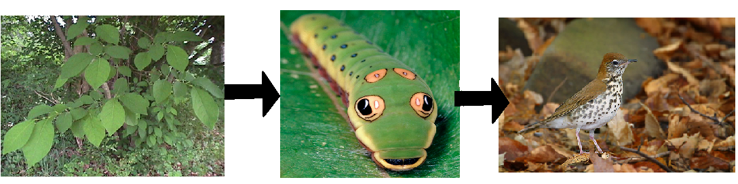

Practice: First, think about the shrub. How does the shrub transform matter and energy? Use the process tool to show how spicebush makes its food.

Spicebush Growing

Energy
Energy

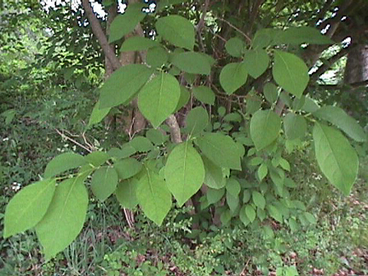

Matter
Matter

Spicebush will use some of the food it makes to keep its cells functioning, and when it uses this food, it gives off gases into the air. But a lot of the materials in plants may stay stored in their body structures, like blades of grass, or branches on trees. This stored material is what becomes food for the caterpillar in the food chain. On the next page, show how matter and energy change when the caterpillar eats the spicebush.
Remember there are two things that can happen to food when the caterpillar eats it. The food can be used for growth or the food can be used for movement.
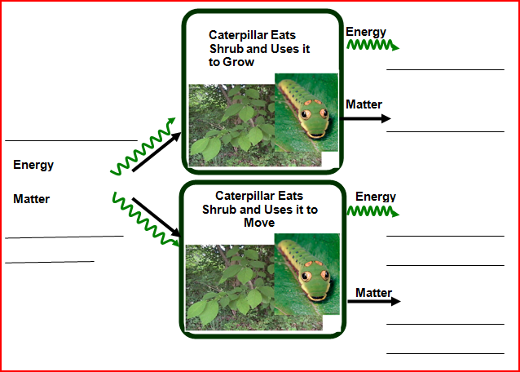

The food the caterpillar eats and uses to move will become part of the air in the atmosphere, so the thrush is not able to have those materials. When the thrush eats the caterpillar, it only gets the materials the caterpillar stored in its body to grow. On the next page, use the process tool to show what happens to matter and energy when the thrush eats the caterpillar.

Remember there are two things that can happen to food when the thrush eats it. The food can be used for growth or the food can be used for movement.

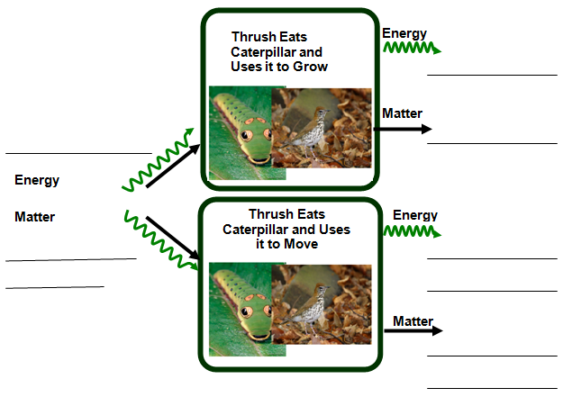

Blank

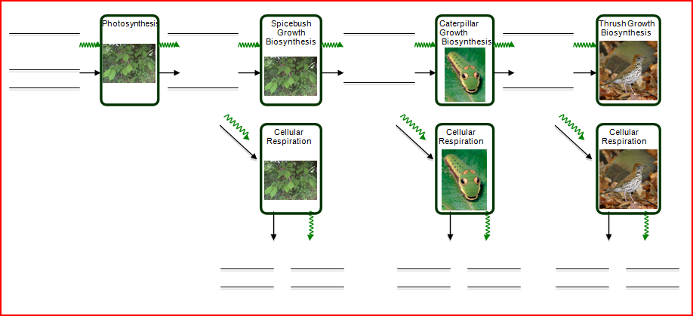

Answer Key

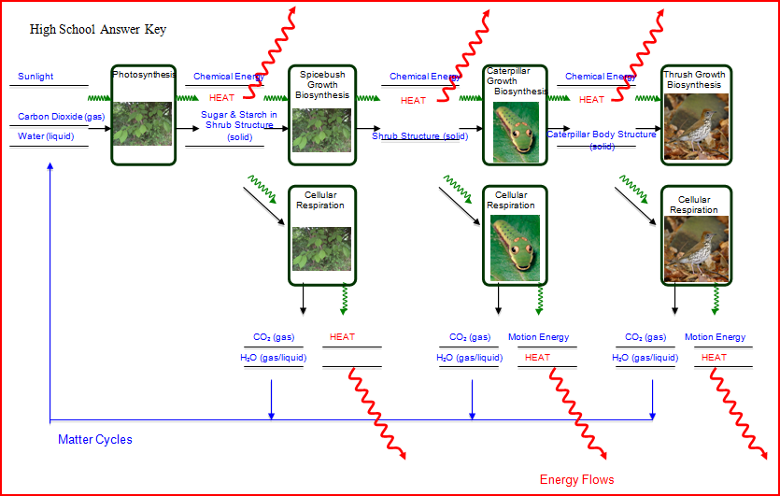

Activity 4: Biomass and Energy Pyramids

Overview
Review Food Chain Process Tools ~10 minutes
Energy Pyramid Activity ~25 minutes
Discussion on Matter and Energy ~15 minutes

TOTAL TIME: 50 minutes

Purpose
This activity allows students to construct simple models that represent inefficiencies in trophic transfer, as a follow-up to the presentation in activity 3.

Materials
Student copies of Island Ecosystem
Process Tool of Food Chains from Activity 3 (spicebush→caterpillar→thrush)

Advance Prep
Make copies of student handouts if not provided by MSU
Have process tool ready for use if needed

Procedures

Review 10 minutes
In Activity 3, students constructed process tools to show how matter and energy move in food chains. Review these process tools. The key concepts to point out to students are that only SOME of the matter and energy an organism receives moves onto the next level; ONLY the matter used to grow and the chemical energy stored in the body can be made available to the next organism because as organisms use food to move and function, they give off carbon dioxide and water and transform energy into motion energy and heat.

Island Ecosystem Activity 25 minutes
Pass out Island Ecosystems. Depending on the number of pennies you can procure, have students complete this activity individually or with a partner (no more than 2 students).

Read through the activity instructions. Explain that this activity is going to help students know about how many organisms can exist in an ecosystem based on the amount of matter cycling and energy flowing through food chains.

Pass out a copy of the organism pictures, at least 27 pennies per student or pair, pair of scissors, and the page with 3 levels.

Have students read through “build your model” on their own and allow them to start constructing their energy/biomass pyramids.

Discussion 15 minutes
When students complete their pyramids, have students share what they observed in the activity.

Students were supposed to add an arrow that shows “chemical energy” moving on in the ecosystem, and energy arrows showing “heat” exiting the ecosystem. Consider also having students draw arrows to show organic matter moving on and carbon dioxide being given off (but cycling back to the trees).

Focus the discussion on the following key questions:
- How many organisms were at each level? (9 trees, 3 giraffe, 1 lion)
- Why were there fewer giraffes than trees? (Because there was less matter and energy made available to the giraffes; the trees used some of the matter and energy and did not pass it along to the next organism).
- Why were there fewer lions than giraffes?
- What happens to the energy that is not passed on to the next organism? (mainly heat; motion)
- What happens to the matter that is not passed on to the next organism? (carbon dioxide and water; feces, perspiration and other excretions; consumed by decomposers)
- If we were to weigh all the lions and weigh all the trees, which do you think would have more mass in an ecosystem? Why? (trees; the vast majority of mass is turned back into gaseous forms and reemitted)

Name: _____________________________________ Date: ______________

Island Ecosystem

In the middle of the Pacific Ocean, there is a small island. Imagine that only two types of animals live on the island: giraffes and lions. There are also trees and grass on the island. The island is a very simplified example of an ecosystem. Assume it is not disturbed by human beings. The ecosystem on the island is at a steady-state, which means that the population of each type of organism does not change drastically over time.

You will use pictures and coins to build a model of the ecosystem.

The pictures of organisms represent the number of organisms in the ecosystem. The picture can also represent the amount of matter stored in that type of organism.


The pennies represent the amount of energy each organism has. For the sake of this example, each organism must have at least three pennies to exist.
- One penny represents the amount of energy each organism stores in its body by growth (this is chemical energy stored in the organism’s body).
- Two pennies represent the amount of energy each organism uses for their bodily functions and movement. This energy eventually turns into motion or heat, and cannot be used by other organisms.

To Build Your Model:

Step 1: Start with Level 1: The Plants. Place a number of trees at the bottom of your model. Place 3 pennies by each tree. Each tree uses 2 pennies and turns these into energy that cannot be used by other organisms (mainly heat). Take 2 pennies away from each tree. Move the remaining pennies to the 2nd level. Based on the number of pennies, do you have enough energy to sustain any giraffes at this level? If yes, how many?

Step 2: Place the appropriate number of giraffes at level 2. Repeat step 1 in order to figure out the number of lions at the third level.

How many trees do you have at level 1? How many giraffes do you have at level 2? How many lions do you have at level 3? Look at the levels, what patterns do you find?

Once your model is complete, draw and label arrows to show the form(s) of energy passing on to the next level. Also draw and label energy arrows that show the form(s) of energy that cannot pass on to the next level.

Imagine a predator was added to the island that only ate lions. Would you expect this new species to persist on the island? Why or why not?

Level 3. Lion

Level 2. Giraffe

Level 3. Trees

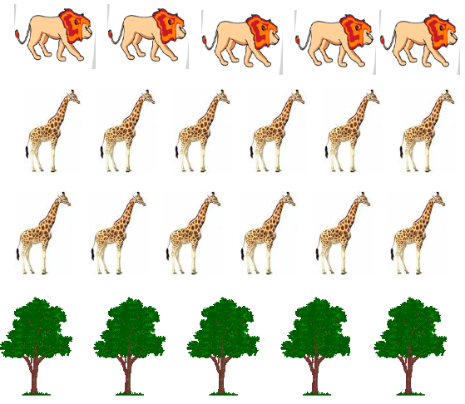
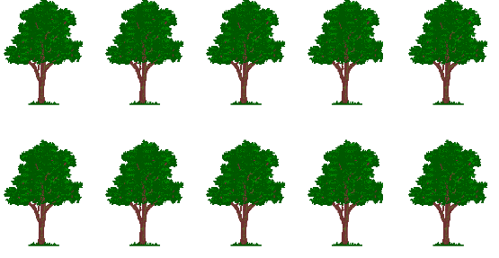

Answer:

If the student first chooses 9 trees, each tree will have 3 coins. Two of them become heat and only one of them goes to the second tropic level – giraffes. Altogether, there are 9 coins at the second tropic level. Since each giraffe needs 3 coins to survive, nine coins can support 3 giraffes. Each giraffe will consume 2 coins and pass on one coin to the third tropic level – lion. Altogether, there will be 3 coins passed on to the third tropic level, which can only support one lion.

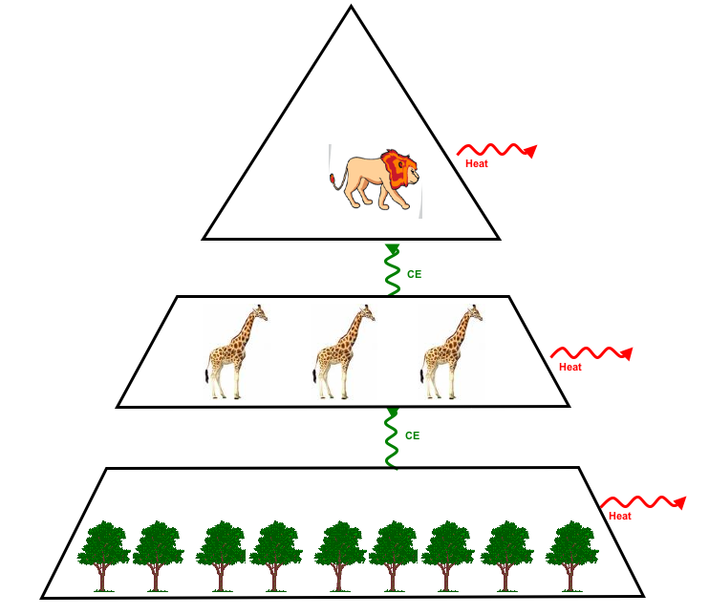
CO₂
CO₂
CO₂
OrgC
OrgC

Activity 5: Putting It All Together (Carbon Reservoirs)

General Overview:
Small Groups: Where does my organism fit in the carbon cycle? ~ 25 minutes
Large Scale Carbon Cycle Diagram ~ 25 minutes

Estimated Time: 50 minutes

Purpose:
This lesson allows students to review and synthesize all of the concepts discussed in the previous activities and/or units: photosynthesis, respiration/decomposition/combustion (as in forest fires), and carbon sequestration. Together, these concepts describe all of the interactions between the bio- and atmospheres in terms of carbon cycling. It is worth reminding students, though, that combustion of fossil fuels is dramatically increasing the rate of carbon movement into the atmosphere, in this case from long-term, geologic carbon reservoirs. The other important processes for carbon in terms of magnitude are exchange between the atmosphere and the oceans, although these are closer to being in balance. While this unit does not cover oceans, they are a critical reservoir for carbon (see Appendix B), and you may want to read up on some of the connections between atmosphere and ocean in case you or your students would like to pursue the idea further. There is a net movement of carbon into the oceans currently, which is slowly acidifying seawater (a problem for discussion in another lesson!).

Materials:
- Student copies of Where is Carbon Dioxide Going?
- Samples of organisms (woody plant [twigs from tree or shrub], herbaceous plant [tuft of grass], herbivore [insect like grasshopper], carnivore [mouse or small bird], mushroom [store-bought], bacteria [on agar plates]); or pictures to provide if season is wrong for gathering samples.

Advance Preparation:
- Run copies of Where is Carbon Dioxide Going (if not provided by MSU)
- Print photos of organisms or gather real examples for kids to use.

Procedures:

Small Group Discussion: Individual Organisms ~25 minutes
Pass out real organisms (dead or alive) or pictures of organisms; 1 organism for each pair of students. Have students think about their organism and answer the questions on their handout.

Then have each pair share their conclusions with the class. Make sure that students are thinking about whether each group’s conclusions make sense. Also, help them start identifying patterns as to which organisms are net consumers or producers of carbon dioxide.

Large Scale Carbon Cycle Diagram ~25 minutes
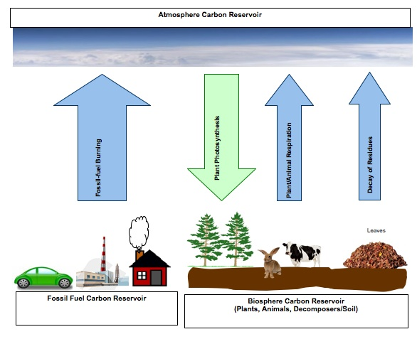
Have students turn over their worksheets. On the backside is a blank diagram. On this diagram students must decide which organisms (and objects) produce carbon dioxide (draw arrows up into the atmosphere to indicate this). They must also decide which organisms consume carbon dioxide.

Consider asking students to draw arrows where the thickness of the arrow indicates the relative magnitude of how much CO₂ is produced or consumed. Also consider having them use two different colors to show the difference between production and consumption.

There are three summary questions that students should answer and discuss during the remaining class time.

Also, consider asking the following questions for discussion:

1. How are the arrows alike and different? Do they all have the same meaning, or do some arrows have different meanings?
2. Are there missing arrows on this diagram? If yes, where?
3. Do you think the amount of carbon in the atmosphere is getting larger, staying the same, or getting smaller? Why do you think that?
4. Do you think energy is also changing when carbon moves? How does energy change? Please choose two arrows to explain.
Name: _____________________________________ Date: ________________

Where is Carbon Dioxide Going?

Understanding carbon movement across entire ecosystems requires thinking about all of the types of organisms involved: plants, animals and decomposers. Please answer the following questions for your group’s organism. Then be prepared to share your answers with your classmates and to listen to their explanations.
1. Does your organism have the ability to transform carbon dioxide into organic forms of carbon?
____________________________________________________________________________________________________________________________________________________________________________________________________________________________________

If so, how much carbon could it remove and store over its lifetime (relative to other
organisms)? Where would it store the carbon?
____________________________________________________________________________________________________________________________________________________________________________________________________________________________________

2. Does your organism have the ability to transform organic carbon back into carbon dioxide?
____________________________________________________________________________________________________________________________________________________________________________________________________________________________________

If so, when and how much carbon would it be sending back to the atmosphere? How do you know this would occur?
____________________________________________________________________________________________________________________________________________________________________________________________________________________________________
3. What are some important ways in which we as modern humans are responsible for moving carbon between land and the atmosphere?__________________________________________
________________________________________________________________________________________________________________________________________________________
Look at the different reservoirs, or locations, where carbon is found in the diagram below. In this activity you will think about how carbon dioxide moves between these locations. Draw arrows going down showing which locations (including organisms) take in carbon dioxide, and identify the process(es) responsible for that movement. Draw arrows going up to show which locations (including organisms) give off carbon dioxide into the atmosphere, and identify the responsible process(es).

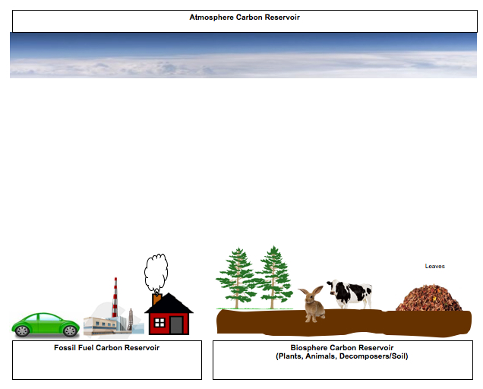
Questions

1. How are plants different from other things in how they move carbon dioxide? ____________________________________________________________________________
____________________________________________________________________________________________________________________________________________________________________________________________________________________________________

2. If the arrows going in and out of the biosphere were equal, what do you think would happen if we decided to cut down trees to make room for a new neighborhood or parking lot?
____________________________________________________________________________________________________________________________________________________________________________________________________________________________________

3. What would happen to the arrow from the fossil fuel reservoir if we chose to have more cars running on gasoline, and used more fossil fuels to power our homes? _____________________
____________________________________________________________________________________________________________________________________________________________________________________________________________________________________

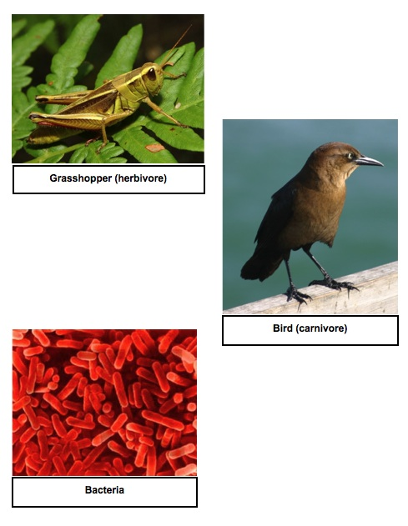

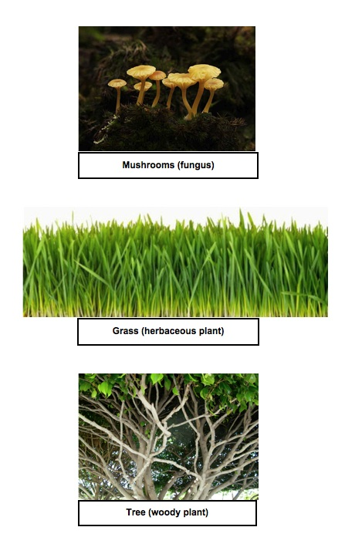

Activity 6: Plants As a carbon Reservoir

General Overview
Introduction: Review of the global carbon cycle, w/ focus on plants. ~ 10 minutes
Small Groups: Exploration of plant types and carbon sequestration. ~ 15 minutes
Whole Class: Implications of plant carbon for global carbon balance. ~ 25 minutes

Estimated Time: 50 minutes

Purpose
This lesson allows students to think more carefully about the important role plants play in global carbon cycling through the processes of photosynthesis and growth. We begin by reviewing the fixation of gaseous CO₂ into plant compounds (initially, glucose), which is one of the primary ways CO₂ is removed from the atmosphere. Then, in small groups, students consider how this general trend plays out in a variety of plant types (annual vs. perennial, woody vs. herbaceous, aquatic vs. terrestrial). Finally, students come back together as an entire class and report on their findings to the rest of the class, helping to inform a discussion on human land use decisions and carbon sequestration.

Materials
- Powers of 10 class poster
- Optional: Internet access and LCD projector for displaying helpful visuals
- Student handouts of Plants and Global Carbon Cycling
- Gather plant materials ahead of time, either real samples or pictures. You will need one example each of: annual plant (possibly corn or other crop grain), perennial plant (turf grass), herbaceous plant (dandelion), woody plant (tree or shrub), aquatic plant (sample of pond water), and terrestrial plant (any potted plant, for example).

Advance Preparation
- Run copies of Plants and Global Carbon Cycling (if not provided by MSU)
- Optional: Set up projector for displaying Internet animations

Procedures
Introductory discussion: Carbon Cycling ~10 minutes
- Begin the discussion by reminding students of the main form of carbon in the atmosphere, and in which contexts they may have heard about it. If they don’t volunteer it, draw out the idea of carbon dioxide as a gas in the atmosphere. Using the Powers of 10 poster, remind students of the incredibly small size of CO₂ molecules, and move into a brief review of how this gas is used by living systems. What vital life process requires CO₂ as a reactant (photosynthesis)? Encourage students to think about the connection between visible plant parts (e.g. stems and leaves) and the atomic-molecular scale of CO₂ in the atmosphere. Obviously plants can remove a lot of CO₂ from the atmosphere in the process of growing their tissues. (Although remind students from earlier lessons that plants also return CO₂ to the atmosphere during respiration).
- If time and technology permits, you may consider showing several brief animations found on the “Habitable Planet” website which illustrate the key points of carbon fixation via photosynthesis and mineralization through respiration. They are found at http://www.learner.org/courses/envsci/unit/unit_vis.php?unit=2, and are the first two animations on the list; each is less than a minute long.

Small Group Discussion: Plant Types and Carbon Storage ~15 minutes
- Have students break up into 6 groups (approx. 4 per group). Distribute the plant samples and/or pictures, one to each group. Have them discuss how much carbon dioxide a plant like theirs is likely to absorb over the course of the growing season, how long it is likely to keep that carbon stored over its life, and what parts of the plant are the largest storage areas for carbon. Make sure they take notes on their discussion and are prepared to share their answers with the rest of the class.
Note: Given the broad categories of plants chosen for this discussion, there are certainly wide ranges of carbon sequestration potential within each category. In general, larger plants or annuals tend to store the most carbon in a given year, while longer-lived species will accumulate large amounts of carbon over their lifetimes. Aquatic producers operate a little differently, though. Their aggregate effect is to sequester a lot of carbon during each growing season due to their very high growth rates (when conditions are good). The majority of this carbon is respired back to the atmosphere that same year though, as decomposers (mainly bacteria in this case) break those cells down.

Whole Class Discussion: Human Land Use Decisions ~25 minutes
- Bring the groups back together and have them share the results of their small group discussions using a blank transparency version of Plants and Global Carbon. After the groups have reported their work, move into a discussion of how human land use decisions can affect global carbon cycling via promoting or discouraging planting of different types of plants. Of particular importance is deforestation, since it replaces long-lived reservoir species with shorter-lived species that will respire back most of their CO₂ on a much faster basis. On the other hand, allowing annual cropland to slowly grow back into forests will lead to a high level of carbon storage while that forest is growing. You can also discuss the difference between annual and perennial plants in terms of storage in root tissues. There is a growing movement to increase the proportion of perennial species used as food crops, not least because below-ground carbon storage is much more significant with these species.

Name: ________________________________________ Hour: __________

Plants and Global Carbon Cycling

Different types of plants can store carbon in their bodies in very different places and for very different lengths of time. Working with your group and the plant sample provided, fill out the following table for your sample. Then listen as other groups report on their sample and fill out the rest of the table accordingly.

Plant Type or Species | How much carbon stored each year? (Little, Moderate, Much) | How long will plant store carbon over its life?  (Short-term, Moderate, Long-term) | Where in the plant will most of the carbon be stored?  (Roots, Stem, Leaves, Other)
Annual Grass (Corn) | Moderate | Short-term | Stem
Perennial Grass (Turfgrass) | Little or Moderate | Moderate | Roots
Herbaceous Perennial (Dandelion) | Little | Moderate | Roots
Woody Perennial (Maple Tree) | Much | Long-term | Stem
Terrestrial (Potted Plant) | Moderate | Moderate | Stem
Aquatic “Plants” (Sample of Pondwater) | Much | Short-term | Other (Single-cell organisms)

1. As people choose how to use different parts of the landscape, which types of plants do you think they should recommend for planting in order to store the most carbon? Which types of plants will be of most help over the longest time? How did you decide that?

2. What is the result for the global carbon cycle if large tracts of forest are cleared and planted with annual plants for farming? How about if abandoned farmland reverts to forest?

Back-up Photos for Plants and Global Carbon Cycling

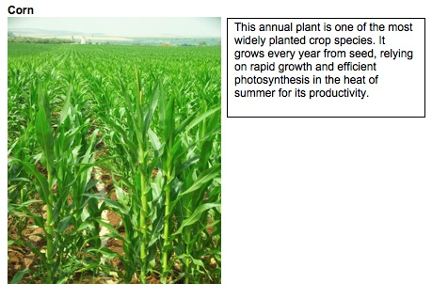
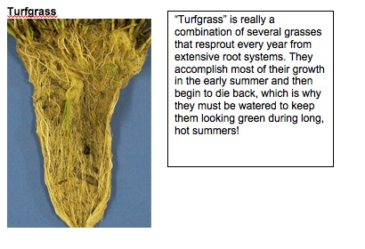

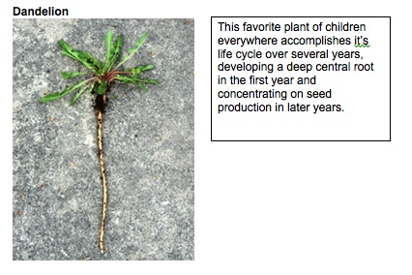
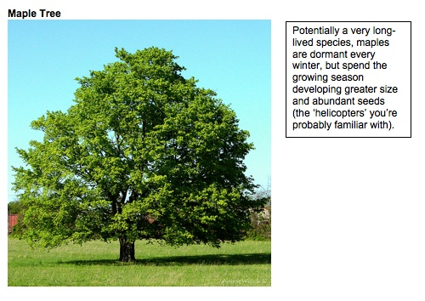
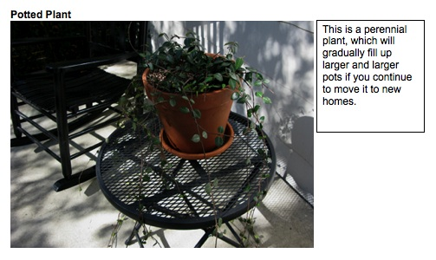

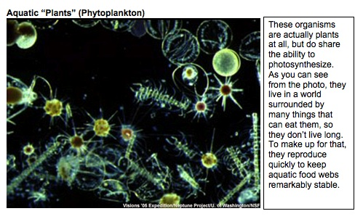
These organisms are not actually plants at all, but they do share the ability to photosynthesize (along with algae and true aquatic plants, like pond lilies). They are surrounded by many animals that like to eat them, so they don’t live long. To compensate, they reproduce quickly to keep aquatic food webs quite stable.

ACTIVITY 7: Soil as a carbon reservoir

General Overview:
Introduction: Review of the global carbon cycle, w/ focus on soil . ~ 10 minutes
Small Groups: What factors can increase or decrease soil carbon levels? ~ 15 minutes
Whole Class: Implications of soil carbon for global carbon balance. ~ 25 minutes

Estimated Time: 50 minutes

Purpose:
This lesson adds to the discussion so far the last major terrestrial component of the carbon cycle: soil organic carbon. Carbon that exists in living organisms often ends up in the soil for varying lengths of time after their death, depending on its composition. Carbon in sugars, proteins and other relatively-simple organic molecules tends to be rapidly released as CO₂ by cell respiration in decomposing organisms, but carbon in more complex molecules, particularly in cellulose and lignin from plants, may remain for quite long periods of time in the soil before being fully decomposed. Students often carry the misconception that carbon from decaying organisms can then be directly taken up by the roots of living plants, forgetting that plants acquire their carbon in gaseous form during photosynthesis. Keep an eye and ear out for this way of reasoning during this activity.

Materials:
- Student handouts of Soil and Global Carbon Cycling
- Samples of plant litter and soils from several habitats (forest, grassland/pasture, farm field); or use pictures if season is wrong for gathering samples

Advance Preparation:
- Run copies of Soil and Global Carbon Cycling (if not provided by MSU)

Procedures:
Introductory discussion: Carbon Cycling ~10 minutes
- Begin the discussion by asking students to list some of the major forms of carbon in the biosphere and atmosphere (CO₂, organic carbon w/ specific examples of molecules). Although they are likely to be very familiar, at this point, with living organisms respiring CO₂ during regular metabolism, encourage students to consider what happens to all of the organic carbon that remains after organisms die. If necessary, prompt them to consider decomposers from the earlier lesson, as a way to understand how most organic carbon is eventually respired. Depending on the molecule that carbon is tied up in, though, this respiration can take a long time to be completed if decomposers’ respiratory enzymes cannot easily break the molecule apart. In particular, cellulose and lignin, which are the major components of cell walls (and thus, wood) are very resistant to decomposition, and although they can be mechanically broken into smaller and smaller parts, biological breakdown (and release of CO₂) can take a very long time. The diagram below (from genomics.energy.gov) illustrates the complexity of the polymers within plant cell walls and may give students a visual idea of why complete decomposition of such materials is hard.
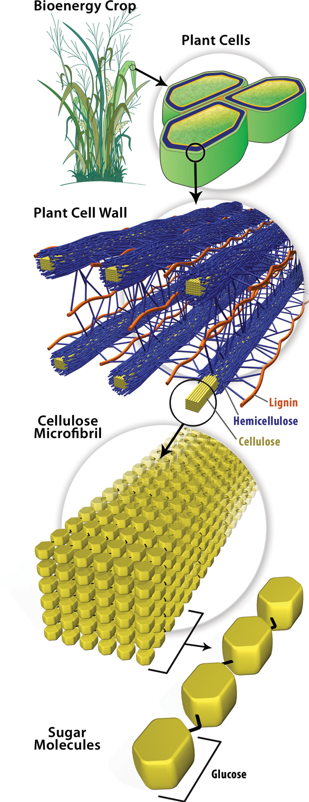
Small Group Discussion: Soils and Carbon Storage ~15 minutes
- Have students break up into 6 groups (approx. 4 per group). Distribute the soil and litter samples and/or pictures, one to each group. Have them discuss how quickly carbon dioxide from their soil is likely to be released over the course of the growing season, how long it is likely to keep that carbon stored over its life, and what parts of the decaying plants will remain in the soil for the longest time. Make sure they take notes on their discussion and are prepared to share their answers & ideas with the rest of the class. If groups are struggling, suggest that they think about ways in which decomposition could be increased (i.e. ways in which decomposers could respire faster). They benefit from the same things more familiar animals do: plentiful oxygen, moderate levels of water and moderate temperatures. The presence of these conditions will speed up decomposition rates in the soil. This may be a good time to use a process tool to review cell respiration as a way to remind students of the important factors. One important cause of this disturbance is agricultural tillage, which is continually introducing more oxygen to the soil. As a result, over time, farmed soils retain very little carbon. The plants growing in farm soils are also mostly annuals, and so don’t have much organic carbon to contribute that is resistant to decay.
Whole Class Discussion: Human Land Use Decisions ~25 minutes
- Bring the groups back together and have them share the results of their small group discussions using a blank transparency version of Soil and Global Carbon. After the groups have reported, move into a discussion of how human land use decisions can affect global carbon cycling by changing decomposition rates in soils. Probably the largest effect we have on soil carbon is by tilling soils for agriculture, where we not only break organic debris into smaller pieces by plowing (thus making it easier for decomposers to work on the pieces), but we also introduce large amounts of oxygen into the soil, greatly increasing the efficiency of the fungi and bacteria doing the bulk of the decomposition. Another effect is via the type of vegetation that we encourage (cf. Activity 8). Because woody species take much longer to decompose, the presence of forests as opposed to crop- and grasslands will keep more carbon out of the atmosphere for longer periods of time. In other words, the important take-home point for students is that soil carbon sequestration (retention) is primarily related to the types of plants growing on that soil, and the degree to which that soil is disturbed. Animal organic matter is not strongly related to soil carbon, simply because nearly all of our organic matter is quickly decomposed by decomposers. One possible exception might be the role of dense grazing communities (bison, cattle, etc.), which increase the speed of breakdown for much plant material after passage through their digestive tracts. In many grassland ecosystems, decomposition of plant material is greatly enhanced by the bacteria present in the digestive tracts of large grazers, such as cattle and other ruminants. These bacteria posses a wide range of enzymes that the mammals don’t otherwise have access to, including enzymes that can break apart molecules such as cellulose.
Name: ________________________________________ Hour: __________

Soil and Global Carbon Cycling

Carbon can remain in organic compounds in the soil long after an organism dies, but different compounds are broken down by decomposers at very different rates. The “woodier” materials of certain plants, in particular, can take decades or even hundreds of years to fully decompose. Specifically, lignin, with its great chemical complexity, takes the longest time to break down, followed by cellulose and then starches. In contrast, ecosystems with few woody species tend to lose soil carbon more rapidly to the environment. Working with your group and the soil sample provided, fill out the following table for your sample. Then, listen as other groups report on their sample and fill out the rest of the table accordingly.

Soil and Litter Type | How long will at least some of the carbon remain in soil?  (Short-term, Moderate, Long-term) | In what form will most of the carbon be present in the soil?  (Lignin, Cellulose, Starch) | How much carbon could be released to the atmosphere by plowing of this soil?  (Little, Some, Lots)
Forest | Long-term | Lignin, Cellulose | Some or Lots
Grassland | Moderate | Cellulose, some Starch | Some or Lots
Annual Cropfield | Short-term | Starch, some Cellulose | Little

1. Is it important to consider the abundance of animals present above a soil when it comes to estimating soil carbon? Why or why not?

2. What kind of human management decisions are most likely to affect soil carbon levels? What would you recommend land managers do to increase or hold steady the amount of carbon stored in soils in this area?

General Soil Samples:

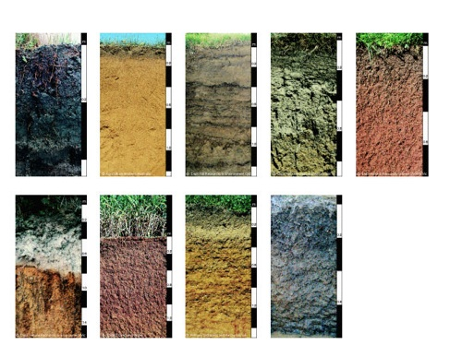

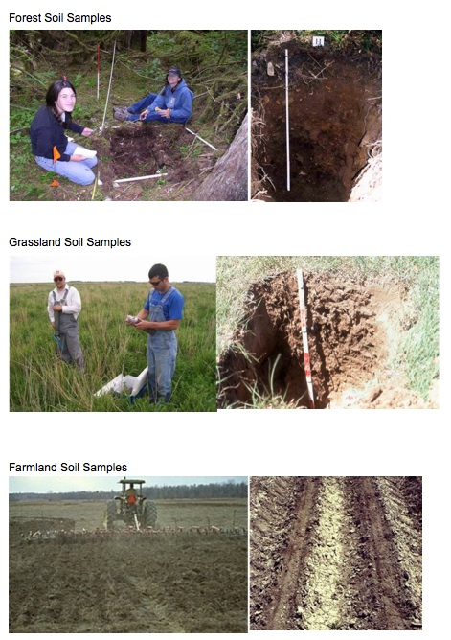

Optional inquiry activities

Activity 8: How are Plants Unique?

Overview
Review Photosynthesis ~10 minutes
Elodea Demonstration/Lab ~30 minutes
Process Tool and Questions ~20 minutes

TOTAL TIME: 60 minutes

Purpose
The purpose of this activity is to introduce students to plants’ critical role in carbon cycling. This activity is not primarily intended to teach photosynthesis, but instead to review what students already know about photosynthesis with a focus on how CO₂ gas contributes to plant mass (i.e., how plants change CO₂ gas into stored organic carbon, thus also storing lots of chemical energy). Students should already be familiar with photosynthesis, but many students may believe that water, soil, or sunlight contribute to plant mass, and may not know or may forget about the CO₂ as the key material in terms of mass. They may also think that sunlight is “food” for plants, but should be supported in tracing energy transformations from sunlight to chemical energy. Students have the opportunity to use the process tool to describe a more complete picture of what happens in photosynthesis. The lab can be used as a demonstration to make plants’ uptake of CO₂ more visible. It shows that plants (using elodea as an example) take in carbon dioxide as indicated by the color change of the BTB indicator. This would fit well between core activities 2 and 3.

Materials
Student copies of How Are Plants Unique?
Process Tool Class Chart and/or overhead for plant growth/photosynthesis
Plant lab (per group)
2-4 sprigs Elodea
2 test tubes with cap or glass jar with lid
1 erlenmeyer flask
1 Straw
.04% solution of BTB
60-watt lamp & bulb or grow light
Plant PowerPoint (zooming into a plant cell)- if available (with computer to project)

Advance Prep
Make Copies of overheads and worksheets if not supplied by MSU
Have Process Tool (chart or overhead) ready for use.
Gather supplies for lab (consider testing lab in advance)

Procedures
Optional Pre-assessment
Which gas(es) do plants take in from their environments? (You may circle more than one)

_____Oxygen _____Carbon dioxide _____Other:_____________
Explain what happens to the gases once they are inside the plant.

Review Photosynthesis ~10 minutes
In order to better understand what students already know about plants and CO₂, review students’ ideas about photosynthesis. Perhaps start by reminding students that they identified photosynthesis as the flux moving carbon from the atmosphere to plants, and follow up with, “If plants take in CO₂, what do they do with it? How is it used?” Allow students to share any of their ideas about photosynthesis. Some common misconceptions about photosynthesis include:
1) CO₂ is a gas and does not contribute much to plant weight (actually carbon from carbon
dioxide makes up at least 50%, and often much more, of plant dry matter),
2) sunlight actually turns into food or matter for plants (violates conservation laws),
3) water is the only or main source of mass (or weight) for plants without attention to CO₂
4) soil contributes to plant mass.

As students share what they know about photosynthesis, be particularly attentive to these common misconceptions. If students mention that plants also take in O2, work with them to recall how plants also need oxygen for cell respiration, just as all living cells do.

Plant Lab and/or demo ~30 minutes
This lab activity shows that plants take in carbon dioxide. Use it either as a lab investigation for students to conduct, or a demonstration conducted by the teacher.

See instructions for the lab on the following pages. Have students conduct or observe the lab using the 2-page lab directions for guidance,and share their observations. Did they find that plants take in CO₂?

Although this is a useful demonstration of CO₂ uptake, it doesn’t make visible for students the location of the carbon in organic molecules (sugar, starch, etc). As a way to address this latter fact, consider using potato slices and a dye that marks starch (like iodine) to demonstrate that plants do in fact have large amounts of carbon-containing molecules.

Photosynthesis Process Tool & Questions ~20 minutes
After the lab activity, use the Process Tool to review photosynthesis with students. Importantly, point out that photosynthesis “sequesters” carbon because it transforms CO₂ into organic carbon (which has chemical energy). Because the carbon atoms are not in the atmosphere while in organic carbon, they are also not constituting a greenhouse gas (the context in which students may have previously heard about carbon sequestration). This is the idea behind purchasing carbon offsets for things like travel: your money pays for projects like large-scale tree-planting, in which the growth of young trees through photosynthesis stores a large amount of atmospheric CO₂ in their tissues.

Also, have students complete the summarizing questions at the end of the activity. Use these questions and student responses to conduct a class discussion.

An important point to make is that plants are made of atoms and molecules that originally came primarily from CO₂ in the air and liquid water. Carbon from carbon dioxide is a hugely important contributor to plant mass and plants are a very important carbon reservoir because they are the primary organisms that transform carbon dioxide back into energy-rich organic carbon molecules for all living things on the planet.

Note: If the PowerPoint is available, use it as a reference to scale. Consider zooming into a plant cell to talk about where the changes are happening in the plant. This can be especially useful as students often struggle to identify how materials move through a plant, given that their tissues and organ systems are quite different than ours.

Optional Inquiry Expansions to Lab: Another way to demonstrate the role of photosynthesis in CO₂ uptake would be to create duplicate sets of tubes and place them in the dark for the same length of time that the others are exposed to light. The lack of color change in the dark should reinforce for students the fundamental role of sunlight. And you can also run tubes in the opposite direction, by starting with low CO₂ levels (i.e.-dye still blue) and allowing tubes with and without plants to incubate in the dark. The plant’s respiration should change the solution color to yellow, just as it would for an animal, helping to underline for students the similarity of all cells in that they all perform cellular respiration.

If you have access to a Vernier probe, setting up a chamber to measure changing CO₂ concentrations during photosynthesis would also be an effective demonstration of this phenomenon.
Is CO₂ an INPUT for photosynthesis?

Procedure

1. Fill a jar with blue BTB to the top and pour it into an Erlenmeyer flask (or other suitable container). Do this one more time, so there are two vials worth of BTB in the flask.
Vial
Blue BTB

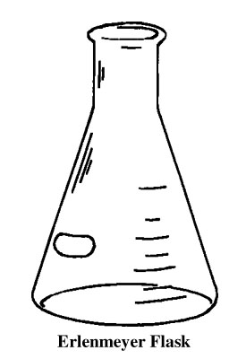

X 2

2. Blow gently into the Erlenmeyer flask with a straw until the BTB JUST turns yellow. Do not blow for too long!

3. Pour the yellow BTB back into the two jars.

4. Put a 2-3 inch long piece of aquatic plant in one jar. Seal both jars tightly!

5. Fill out and tape a label onto your jars.

7. Place jars under the grow lamp on the paper marked for your class. Put the label facing DOWN so it doesn’t block the light.
Fill flask with 2 jars of BLUE BTB
Blow gently into BTB until it just turns yellow. You are adding CO₂.
Pour yellow BTB back into jars
Place piece of aquatic plant into one jar
Seal BOTH jars tightly!
Label both jars and put under light.
BTB turns blue
in plant jar only
BTB stays yellow in
both jars
CO₂ has been removed from the water.
CO₂ has NOT been removed from the water
CO₂ is an INPUT for photosynthesis.
Is CO₂ an INPUT for photosynthesis?
Name: _________________________________________ Date:__________

How Are Plants Unique?

- What forms of matter and energy go in and out of plant cells during photosynthesis? Complete the diagram below.

- If someone claimed that a plant’s mass comes from CO₂ in the air, explain why you agree or disagree with that statement. __________________________________________________
___________________________________________________________________________________________________________________________________________________________________________________________________________________________
- Why are plants so important for other living things in terms of what they do with energy? What do they do that most other organisms cannot? _________________________________________________________________________
___________________________________________________________________________________________________________________________________________________________________________________________________________________________

Activity 9: What Happens to dead plants and animals?

Overview
Introduction and review ~10 minutes
Decomposer Lab review ~20 minutes
Process Tool and Discussion ~15 minutes

TOTAL TIME: 45 minutes

Purpose
This activity provides opportunity for students to see more concretely that decomposition is the same process as respiration, only it is done by organisms that are largely microscopic (in fact, one simple addition to this lab would be to have students study the organisms they can find on a sample of compost using a dissecting microscope). The lab is fairly flexible in terms of measuring CO₂ production and in terms of the compost/decomposing material used, so feel free to fiddle with these variables depending on what you have to hand, and the interests so far of your students. This lab would perhaps work best after core activity 4.

Materials
Student copies of Decomposition Questions
Process Tool

Lab
Rotting materials (compost or apple)
Digital balance
Cup or other container
Sealed container
BTB
Test tubes (connected to each other with stoppers, tubes)
***some materials may be optional depending on the chosen lab

Advance Prep
Depending on the lab chosen for the decomposer activity, this may require several days of data collection in order to see noticeable amounts of mass decrease. Consider setting this up several days in advance with the students, and then collecting data at multiple intervals. Use this activity when the results will allow for good discussion of mass change during decomposition.

Make copies of student handouts if not provided by MSU
Have process tool ready to use for Decomposition

Procedures
Optional Pre-assessment
A loaf of bread was left uncovered for two weeks. Three different kinds of mold grew on it. Assuming that the bread did not dry out, which of the following is a reasonable prediction of the weight of the bread and mold together?

A) The mass has increased, because the mold has grown.
B) The mass remains the same as the mold converts bread into biomass.
C) The mass decreases as the growing mold converts bread into energy.
D) The mass decreases as the mold converts bread into biomass and gases.

Please explain your answer.

Introduction
Ask students the following question: What happens to dead plants and animals? Elicit students’ initial ideas about decomposition. (What do they think happens to all the molecules that make up plants and animals, when the organisms die?)

Tell students that they are going to learn more about how decomposition is related to changes in dead plant and animal materials, and how it changes the composition of air. Ask students what they know about decomposition: What are decomposers? (bacteria, fungi, macroscopic detrivores like worms). What do decomposers “eat,” and why do they eat that stuff? This is also a good point to bring in the Powers of 10 diagram, and discuss how much smaller many decomposers (e.g. bacteria and fungi) are than the more macroscopic organisms they are decomposing. This is a part of why the process of decomposition can feel relatively mysterious to students.

Decomposer Lab Review
Conduct a lab investigation with students to test the change in mass and release of CO₂ from a rotting apple or compost material. Because of the time it takes for decomposition to occur, consider setting this activity up several days in advance and collecting mass readings once a day until the pattern in mass change is clear.

In order to conduct this lab, either bring in composting material or an apple to your classroom. Make sure to get an initial mass of the material. Place a cup or container on your digital balance (as a backup, note the mass of the cup or container). Then zero out the scale. Add the material to the container and record the starting mass.

Over several days, record the mass of the material until a pattern is detected. The mass should decrease due to cellular respiration.

Alternative suggestions to detect CO₂:

Consider using BTB indicator to detect CO₂ gas as a product of decomposition. You can do this by connecting a test tube of decomposing material to a test tube of BTB. Make sure the system is sealed. Over time the BTB will turn yellow.

OR

Place a piece of apple or a mass of compost in a sealed container with a cup of BTB. Overtime the students should observe water collecting on the inside of the container and the BTB indicator turning yellow, indicating the release of CO₂ and H₂O. By weighing the system before and after incubation, they should also see that the total mass doesn’t change.

OR

If you have Vernier probes and chambers, you can easily set up the probe to record CO₂ and O₂ changes in a sealed chamber as material decomposes. You will likely even be able to see changes in these gas concentrations over the course of one class period, and the continuous recording possible with these instruments also opens up good discussion possibilities.

When the lab observations are complete, use the results from the mass investigation and the indicator investigation to help students complete their process tools. An additional advantage of sealed containers is that students can see that the overall weight of the system doesn’t change over the course of several days, even as the mass of the detritus does decrease from start to finish.

NOTE: If your school has compost available, consider showing students the compost, especially if the compost pile shows signs of giving off heat.

Process Tool and Summarizing Questions

Consider the following questions:
- How does decomposition show matter transformations?
- How does decomposition show energy conservation?

When discussing the first question, help students explain that ultimately the dead plant and animal material is used as food for the decomposers and that they give off waste products that are in the form of gases (CO₂ & H₂O), so ultimately the dead plant and animal material becomes gases. In regards to the second question, decomposers also release heat during their life processes, and that more of the chemical energy locked in decomposing material is eventually released for use during metabolism by other organisms.

Review the remaining questions on the student handout.

Name: _____________________________________Period/Hour:__________

Decomposition Questions
- What types of matter and forms of energy go into and out of mold cells during the decomposition of bread? Complete the diagram below.

2. Think about how matter is transformed during decomposition. Would you agree or disagree that most dead plant and animal materials eventually become gases that go into the air? Support your ideas. ______________________________________________________________________
________________________________________________________________________________________________________________________________________________________________________________________________________________________________________________________________________________________

3. Decomposition is a process where decomposers use chemical energy found in dead plants and animals. What happens to the chemical energy in this process? How does it change? ______________________________________________________________
__________________________________________________________________________________________________________________________________________________________________________________________________________________
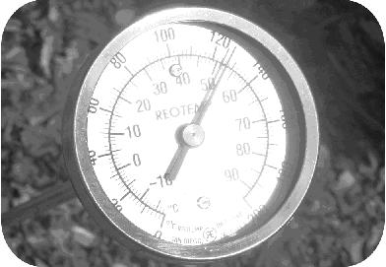
4. The picture shows a long stem thermometer inserted into a compost pile. The temperature reads 51°C (or 124°F). It is not uncommon for compost piles to reach this temperature, and they can even reach temperatures that exceed 60°C.
Think about how energy changes during cellular respiration, and explain why the temperature of compost can be so high, even if it is in the shade. ______________________________________________________________________
__________________________________________________________________________________________________________________________________________________________________________________________________________________

5. Why do you think decomposition is important in the global carbon cycle? ______________________________________________________________________
__________________________________________________________________________________________________________________________________________________________________________________________________________________

6. How do decomposers change the relative amounts of organic carbon molecules and carbon dioxide molecules that we have in the carbon cycle? ____________________________________________________________________________________________________________________________________________

Activity 10: Measuring Soil Respiration (2 DAYS)

General Overview:
Day 1: Introduction: Review of the global carbon cycle, w/ focus on soil . ~ 10 minutes
Lab Set-up: Gathering soil samples and preparing microcosms ~ 40 minutes
Day 2: Lab: Titrating measurements of CO2 production ~ 35 minutes
Discussion: Comparisons of hypothesized to actual measurements ~ 15 minutes

Estimated Time: 50 minutes (Day 1), 50 minutes (Day 2)

Purpose:
This lesson complements the last three core activities, particularly Activity 7, by allowing students to test hypotheses about relative amounts of CO₂ respired from various soil types. It involves creating microcosms (small, simplified models of a real ecosystem) in which students can capture the carbon dioxide being respired from a soil sample via a basic solution within the same closed volume. This then allows students to compare respiration rates from a variety of soils (some possibilities: agricultural soils, lawn soils, forests, prairies/old fields, cold soils, warm soils, etc.).

Materials:
- Fresh soil from desired habitats
- Wide-mouth mason-type jars with lids (pints)
- 30 ml centrifuge tubes or similar vials
- 1 ml pipettes
- 25 ml burettes
- analytical balances (accurate to at least hundredths of a gram)
- Chemicals: 1M NaOH, 1M HCl, BaCl₂ (optional), 50% solution Phenolphthalein

Advance Preparation:
- If collecting soils near the school is not feasible, you will need to collect soils from a few different habitats, or a larger amount of soil from one habitat, ahead of time for students to make their microcosms with.

Procedures:
Introductory discussion: Carbon Cycling ~10 minutes
- Begin by briefly reviewing the global carbon cycle with the students, potentially using the landscape scale diagram (Appendix B). Then ask them to elaborate on the connection between soils and the atmosphere. What is the process that moves carbon between these pools (decomposition), and in what form is the carbon (CO₂ gas)? What things influence the rate of decomposition (temperature, moisture, oxygen, etc.)?
- Break the students into lab groups of 3-4 students each, and have them brainstorm several hypotheses that they would be interested in testing (related to the soil samples you have collected, if necessary). Remind them that they will be testing the abundance of CO₂ emitted by decomposers from a particular soil over a certain length of time. Thus, they may predict that soils of a particular habitat will have more organic matter in them that can decompose, or that the organic matter will be of a more or less decomposable material (i.e.- woody vs. herbaceous tissue). Or they may predict that cooled versions of the same soil will promote decomposition at different rates than room temperature or heated versions. Additionally, you could experiment by adding materials that students might expect would stimulate the rate of decomposition (e.g. – fertilizers, table sugar, etc). Encourage the students to remember with all of their predictions that decomposition is ultimately cell respiration by (mostly) microscopic organisms. Variables that are likely to help or harm those microorganisms will directly affect soil respiration rates. Also remind them that the measurements they take are incorporating the respiration from a huge number of organisms in the soil, not just one or a few. Students may desire to do two or three replicates of their experimental treatments to get a sense for the amount of variability that exists from sample to sample. Do not be surprised if variability in the data from this experiment is somewhat higher than that for many school science experiments. Soils can be very patchy in the distribution of organisms, resulting in wide variability in respiration rates across quite small spatial scales.

Laboratory Set-up ~40 minutes
- Use lab tape to label each microcosm with your name and a unique number, then weigh approximately 150 g soil, add it to each jar, and record the mass of soil added to each microcosm (it is not important to get exactly 150 g soil, as long as you note the actual amount).
- Once the soil is in the jar (and before it is sealed), add enough water to make the soil moist, but avoid water pooling at the bottom of the microcosm. You want nice, moist soil (Why? Moderate moisture levels encourage activity by decomposer microbes). 15-20 ml is typically sufficient for this. If your experiment involves additives (like fertilizer or sugars), mix these in with the water before adding to the microcosm. Each group will also need to set up one control microcosm, which contains no soil but does include an open vial of hydroxide to function as the CO₂ trap (see below). Pause at this point to make sure you understand why we have set up the design as it is. Why do we have to go through this complicated set-up to measure CO₂ concentrations? (Since it is a gas, it is difficult to measure directly) Why are we interested in CO₂ in the first place? (It’s the product of soil respiration by decomposer microbes.)
- For each microcosm (including replicates and controls), prepare one CO₂ trap by labeling a 30 mL centrifuge tube to correspond to their microcosm. Carefully dispense 15 ml of 1 M NaOH to each of the 30 ml centrifuge tubes (caution: sodium hydroxide is caustic; wear safety goggles during these steps).

- Gently press the CO₂ trap for each microcosm into the soil far enough so that the opening of the trap is below the mouth of the jar by at least one centimeter. Carefully wipe all soil from the rim of the jar and slightly moisten the rubber seal in the lid with a damp paper towel.
- Seal the lids of the jars tightly, but DO NOT seal the CO₂ traps. Incubate your microcosms as your experimental design specifies.
Note: The microcosms will allow students to calculate CO₂ released from the soil, since the gas will diffuse into the NaOH mixture, creating carbonic acid (H₂CO₃). This acid will then be titrated on the measurement day, allowing for a calculation to be made of CO₂ concentration. Here is the relevant equation: 2 NaOH + CO₂ gas → H₂CO₃ + 2 Na⁺ + O²⁻

Laboratory Measurements ~35 minutes
Option 1 (pH Meters: easier to set-up and more intuitive connection for students; potentially less precise in terms of measurements)
- Instead of using NaOH in the microcosms, use pure distilled water (so starting pH = 7.0). As the microcosms incubate, carbon dioxide gas will dissolve into solution, creating carbonic acid (H₂CO₃). By using accuarate pH probes (such as Vernier brand), you will be able to note small drops in the solution’s pH as time passes. The larger the drop in pH, the more acid has been created in the solution, and thus the more CO₂ has been respired into the “atmosphere” of the microcosm. Comparing final pH values of microcosms with different types of soil treatments would be a quick way to qualitatively compare soil respiration rates.

Option 2 (Titration measurements: more intensive in chemistry knowledge and equipment requirements; more precise in terms of readings taken)
- Open one microcosm at a time, carefully lift out the CO₂ traps, and seal them tightly with a cap. Avoid splashing any of the NaOH solution. The trap can be titrated immediately or saved for later.
- Transfer the NaOH solution to a 50 mL beaker by pouring, then add 2-3 drops of phenolphthalein and 1.0 ml of 50% BaCl₂. Note for advanced students: Phenolphthalein acts as a pH color indicator that changes from pink to clear at approximately pH 8.2. BaCl₂ precipitates carbonate as insoluble barium carbonate (only necessary if using hard water with a lot of latent carbonates in it).
- Use a burette to titrate the NaOH solution with 1 M HCl. Titrate slowly (add 0.5 ml at a time) and swirl gently until the solution changes from pink to white-clear. Approach the endpoint slowly because the color change occurs quickly. Record the exact volume of acid required.
- Calculate the amount of CO₂ produced using the following formula:
Milligrams (mg) C or CO₂ = (B-V)*NE, where:
B = Volume (ml) of HCl to titrate NaOH in the CO₂ collectors from the control
V = Volume (ml) of HCl to titrate NaOH in the CO₂ collectors from the samples
N = the normality of the acid (for HCl, 1N = 1M, so N = 1)
E = equivalent weight. If results are expressed in terms of carbon, E = 6; if expressed as CO₂, E = 22.
Divide the result for each microcosm jar by the mass of soil in that jar in order to express the results as mg of CO₂ produced per gram of soil.

Concluding Discussion ~15 minutes
- After students have finished their titrations and have calculated the amount of CO₂ produced by their soil microcosms, give them a little time to compare their results to their hypothesized findings. Then bring the class back together to talk for as much time as you would like about their results. Did they find the patterns they expected? What kinds of soils or conditions led to the most carbon dioxide production, or the least? Why?

Acknowledgements
This activity was initially developed by members of the Great Lakes Bioenergy Research Center at the University of Wisconsin, Madison (Steve Laubach, Teri Balser, Kevin Budsberg). We thank them for allowing us to adapt it for this purpose.
Possible Lab Worksheet: Soil Carbon Respiration

Hypothesis: State exactly what you are testing
Rationale: State exactly why you are testing your hypothesis.
Experimental setup: Describe how you will test your hypotheses (include how you will use controls and replicates).
Variables: Explain exactly how you will compare soil types or alter the soil to test your hypotheses.
Microcosm label | Variables tested | Incubation temp. | Replicate? | Mass of soil | mL HCl needed to clear | mg CO₂/g soil
Control – no soil | CO₂ in air | Room temp | Yes | 0 g
Control – no soil | CO₂ in air | Room temp |  | 0 g

optional Account-Building activity

Activity 11: Organisms Give Off Carbon Dioxide

General Overview
BTB Demo- Where Does the ‘C’ in CO₂ come from? 10 minutes
Process Tools for Animal Growth and Movement 25 minutes
Process Tool for Plant Growth and Use 15 minutes
TOTAL TIME: 50 minutes

Purpose
The purpose of this activity is for students to learn that all living organisms engage in cell respiration, which causes organic carbon to ultimately be converted to CO₂ in the atmosphere. The activity starts with a demonstration that people breathe out CO₂. Students share their ideas about where the carbon comes from. Students use the process tool to construct a more complete picture of animal processes (animals breathe in O₂ and take in food, and give off CO₂ and H₂O). Students also use the process tool to talk about how animals transform energy, depending on whether they are growing or moving. Students then connect animal processes to plant respiration. This is best used in conjunction with inquiry activity 8, between core 2 and 3.

Materials
Beaker of BTB solution
1 straw
Process tool for Animal Growth, Animal Movement, Plant Growth, Plant use/respiration
Copies of student pages Organisms Give Off Carbon Dioxide

Advance Preparation
Assemble demo materials
Make copies of student page if necessary
Have process tool ready for use

Procedures
Optional Pre-assessment
Humans get oxygen from the air they breathe, and they exhale carbon dioxide.
a. Where in the body does the oxygen get used?
b. How does the oxygen get used?
c. How is the carbon dioxide produced in the body?

BTB Demo ~10 minutes
Remind students that previously they observed that plants take in CO₂ and that plants are extremely important for carbon cycling because they take in large amounts of CO₂ and store it in their tissues, potentially for long time spans. They are also critical because they are the primary organisms that transform light energy into chemical energy for themselves and other living things.

People and other animals are not like plants in the sense that we do not use CO₂ as a reactant for chemical processes inside our bodies. Instead we give this gas off when we exhale.

Blow into a beaker of BTB. The indicator will turn yellow if CO₂ is present. Ask students, “If I breathe in O₂ and breathe out CO₂, where does the carbon atom come from?” Note that this activity does not teach the details of cell respiration in organisms, but instead uses the process tool to trace materials and energy in different macroscopic events, like growth and movement.

Process Tool for Animal Growth ~10 minutes

Pull out the process tool for Animal Growth.

Ask students what are the key materials that we take into our bodies. Note that ideally you will be looking for them to name “Air/Oxygen” and “Food”, but students might also name water. Tell students that water is very important to our bodies, but mostly as the medium in which food chemicals and oxygen react inside our cells. Write down Food (liquid or solid) and Oxygen (Gas).

Ask students if either of those materials indicates something about how we get our energy. Students should recognize that food has chemical energy. Write chemical energy on the tool.

Then ask students what happens to the parts of food and air that help us grow; that stay in our bodies. Note that the materials eventually become “part of our body structures” mainly in solid forms. This means that when we grow, we are storing chemical energy.

Process Tool For Animal Movement ~15 minutes

Use the process tool to show animal movement. Tell students that a lot of the food we take in is used by cells for our daily operation, including movement from place to place.

Ask students what happens when they exercise a lot (they breathe in more air/oxygen, breathe out a lot more carbon dioxide, get warm, sweat, get tired, etc). Have 1 or 2 students come to the front of the room. Consider having them do jumping jacks, push-ups or the like, enough to get their heart rate up. Ask students what materials they are taking in (oxygen is the obvious one). Ask them if they think the food the kids ate in the morning is helping them move. After students have completed the jumping jacks/ push-ups have them blow into a beaker of BTB. The indicator should turn bright yellow very quickly.

Use other evidence during exercise to help students complete the process tool - they are using chemical energy in food and it is turning into motion energy (the movement) and heat (getting warm).

The food and oxygen are chemically reacting to release carbon dioxide (BTB indicator demo) and water (sweat is the most obvious example, but we also exhale water vapor – as on a cold winter’s day).

Plant Process Tool ~15 minutes

Tell students that plants are like all other living organisms. They don’t just make their food to store it, and they don’t just make their food for other living things. Like animals, they also use food to keep their cells functioning (tracking CO₂ production using a Vernier probe and sealed chambers would be one way to demonstrate that for the students).
Have students complete the process tools on Organisms Give Off Carbon Dioxide.
With the remaining time, have students share their Plant Process Tools.
Name: _____________________________________ Date: ___________

Organisms Give Off Carbon Dioxide

When people breathe they give off carbon dioxide. This is true for other animals too. Even plants and decomposers give off carbon dioxide. But this is not all that happens inside animals.

1. Use the process tool to show how animals transform matter and energy when they grow and move.

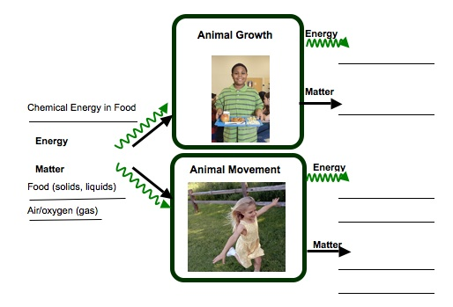

Plants are different from many other organisms because they take in carbon dioxide and make their own food (glucose) through the process of photosynthesis. They are some of the only organisms on Earth that can transform light energy into chemical energy. But plants do not make glucose for us! They make their food so they can store it (and grow) or use it to keep their cells working.

2. Use the process tool to show all the ways that plants transform matter and energy.

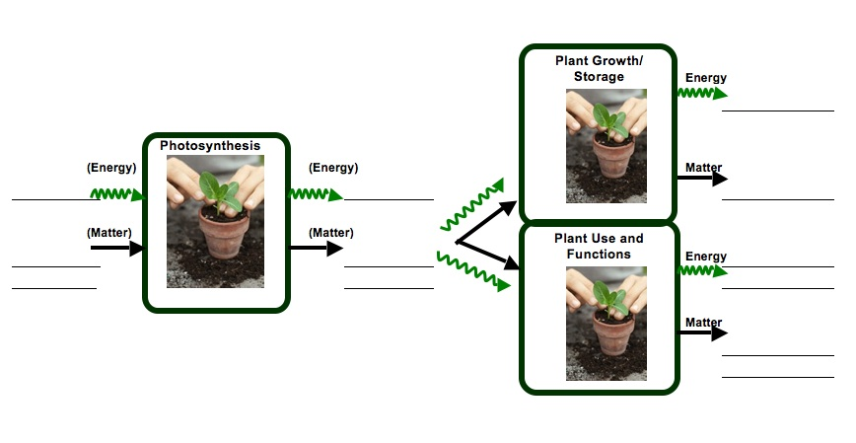

OPtional citizenship activity

Activity 12: Bio- and fossil fuels – what’s the difference?
General Overview:
Introduction: Society’s use of fuels ~ 10 minutes
Group Activity: Tracing the Carbon ~ 20 minutes
Discussion: How far can biofuels go? ~ 20 minutes

Estimated Time: 50 minutes

Purpose:
This lesson can act as an accompaniment to the discussion of global carbon cycling in lesson 5, although students will be able to bring more background to bear on the issue if it is used after lesson 7. It focuses on the key distinction between bio- and fossil fuels, namely that fossil fuels are combusting organic matter that was incorporated into plants via photosynthesis eons ago, while biofuels combust material that is much younger (1-100 years old). Thus, if all fuels used were biofuels, levels of atmospheric carbon dioxide concentration would remain relatively level. But since we are reintroducing carbon into the atmosphere that was in long-term storage when we consume fossil fuels, we are changing atmospheric CO₂ levels dramatically. After this lesson, students will hopefully be able to understand and articulate much more fully arguments around the use of biofuels in our society.

Materials:
- Handout: Tracing the Carbon
- Overhead or board for discussions
- Overhead transparencies of macroscopic and landscape scale carbon cycles

Advance Preparation:
- Make copies of student handouts, if not provided by MSU

Procedures:
Introductory discussion: Society’s use of fuels ~10 minutes

Begin by asking students what connections they may already be aware of between the carbon cycle and uses of fuel in our modern society. Ideally, they should be able to talk about combustion of fossil fuels like coal, oil and natural gas as a significant contributor of carbon (in the form of CO₂) to the atmosphere, where it is acting as a greenhouse gas and thereby contributing to global climate change. If they are struggling to identify these connections, you may prompt their thinking by referring back to the lesson on “energy-rich materials” in Systems and Scale.

Next, ask the students whether they have heard about biofuels, and if so, what they have heard about them. This may generate a range of responses, but try to steer the conversation towards the idea that biofuels act ultimately like fossil fuels, except for the important fact that they rely on combustion of carbon-containing molecules where the carbon was recently (i.e. < 50 yrs. or so) present in the atmosphere as CO₂, rather than millions of years ago as with fossil fuels.

Small Group Activity: Tracing the Carbon ~ 20 minutes

Have your students break up into pairs, or at most groups of three, in order to complete this activity. Hand out a copy of Tracing the Carbon to each group, and then assign half the groups to work on the fossil fuel portion, and the other half to complete the biofuel portion. After about 10 minutes, or whenever the groups seem to have completed their work, have them share their findings with a neighboring group that completed the opposite half. Give them time to teach each other for a while, before drawing the whole class back together to summarize the patterns that they should have seen. You may find it useful to use either or both of the two carbon cycling diagrams to illustrate the differences in the flow of carbon in both situations.

Discussion: How far can biofuels go?

Hopefully, at this point, your students feel pretty comfortable describing why the use of biofuels would be preferable to fossil fuels in terms of maintaining steady CO₂ concentration in the atmosphere. A look at the current scope of our societal energy production and use, however, should illustrate just how far we have to go before this is a viable option. The following diagrams depict the sources of energy produced and consumed in the U.S. in 2007. You may consider copying them in their entirety for students, or just highlight a few of the salient percentages (such as the comparison between “non-hydro renewable” and petroleum used).

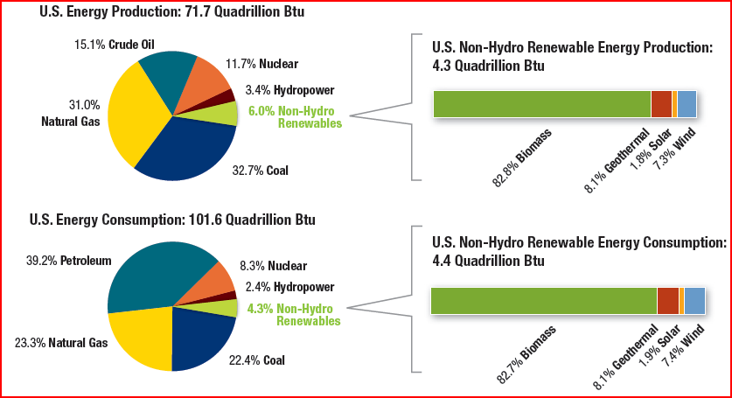

Another aspect of this discussion you may want to bring up, if there is time, is that not all fuels can act the same way. Solar and wind power can generate electricity, but since most transportation currently relies on liquid fuels, that sector is particularly reliant on fossil fuels at the moment. And finally, especially if your students seem discouraged at this point, remind them that energy conservation can make an immediate and noticeable impact on our carbon emissions, starting today! For more on this, see the Energy Consumption unit.

Name: ________________________________________ Hour: __________

Tracing the Carbon
Biofuels have been in the news recently as one way in which our country can use fewer fossil fuels, with benefits to both our economy and the world’s climate. Ethanol, in particular, has been identified as a liquid fuel that could replace large portions of our petroleum consumption. Currently most ethanol is made from corn grain, but large amounts of research are attempting to generate ethanol from other plant parts, including those composed largely of cellulose (i.e. wood-like parts of plants, including actual wood, corn stalks, etc.). Just like gas from oil, though, ethanol is combusted in the engines of vehicles to power their movement, and waste gases are still pushed out of their tailpipes. Then why would this fuel potentially be a good way to reduce global climate change? Working through the activity below should give you a better understanding of the differences between bio- and fossil fuels.
In the table below, describe the path of a carbon atom from CO₂ in the atmosphere to the fuel and back to the atmosphere as best as you can, by considering how the process mentioned would change the location of the carbon. Several boxes have been filled in for you. For other hints, you may want to think back to the “Energy Rich Materials” lesson you saw earlier in the year. For the “Time Frame” column, use your best guess; getting the exact answer is not as important as the relative lengths of time involved.

Step | Fossil Fuel (form of Carbon atoms) | Fossil Fuel (Time Frame in this step) | Biofuel (form of Carbon atoms) | Biofuel (Time Frame in this step)
 | CO₂ (gas) |  | CO₂ (gas)
Photosynthesis | Plant sugars | Hours to days | Plant sugars | Hours to days
Transformation | Cellulose | Days to years | Cellulose | Days to years
Transformation | Hydrocarbons | Millions of years | Ethanol | Years
Combustion | CO₂ (gas) | Hours to days | CO₂ (gas) | Hours to days
Talk with a neighboring group to see how they described carbon movement in their fuel type. What is the key difference between a biofuel and a fossil fuel?

APPENDIX A: BACKGROUND FOR TEACHERS
Our work on the Environmental Literacy Project has focused on the accounts students have for events that occur in natural and managed (i.e.- human societal) systems. In terms of energy and matter, especially carbon, we have documented students’ accounts of growth (plant and animal), weight loss, decay and burning at the macroscopic scale. At larger, global scales we have also looked at their accounts of global warming and deforestation. One overall goal of our work has been to develop a learning progression that describes how accounts of changes in matter and energy develop from grades 4-12. An important conclusion from this work, and our experiences in classrooms, is the following: When students enter school they use narratives (or stories) to explain how the world works. This is the students’ natural discourse. The information they learn in science class teaches them more detailed narratives and new vocabulary, and students try to fit the new information into their existing narratives. Thus, students tell the same stories with more details, instead of learning new, more principled accounts about their world. This limits their ability to apply their knowledge outside of the boundaries within which they first learned it, and thus hampers their capacity to bring this knowledge to bear on everyday decisions they will make as citizens for the rest of their lives.

Our carbon cycle learning progression describes what we observed from students at different levels and different age groups. We used this information to design classroom materials that support progress toward building new accounts about the world—specifically to build principled accounts about carbon cycling.

The carbon cycle learning progression levels is comprised of four Levels of Achievement:
- Level 1 students (at the lower anchor of the learning progression) use force-dynamic reasoning (Pinker, 2007; Talmy, 1988) in which actors (e.g., animals, plants, flames) use enablers (e.g., air, water, food, fuel, sunlight) to fulfill their natural tendencies. Events result from the interplay between the natural tendencies of agents and the balance of forces between enablers that support actors in fulfilling their capacities, and antagonists, which can prevent this from happening.
- At level 2 students are still guided by force-dynamic reasoning, but can point to hidden mechanisms that move beyond natural tendencies and begin to recognize the need to trace materials in and out of systems. Gases are treated more like conditions as opposed to “real matter” and matter and energy are not distinguished.
- At level 3 students begin to recognize chemical changes at a cellular and atomic-molecular level and use chemical identities for several important substances. Some level 3 students attempt to conserve both matter and energy without necessarily knowing great detail about chemical substances and processes. However, some level 3 students also may have difficulty with consistently applying conservation principles (i.e., convert matter and energy; ignore gases).
- At level 4 students see events as “chemically” similar or different and can reason about events in terms of chemical substances and processes. They can also fluidly move between different scales in their reasoning.

In general, most (69%) middle school students give level 1 and 2 accounts on our assessments. Only 20% of students give level 3 accounts. Therefore, an important goal for middle school students would be to get them to make progress toward level 3 reasoning. High school students perform only moderately better, with 52% using level 1 or 2 accounts, and 45% using level 3 or 4 accounts. For both groups, students need support in recognizing and using important principles to guide their reasoning.

APPENDIX B: TOOLS

Simplified Spicebush Food Chain
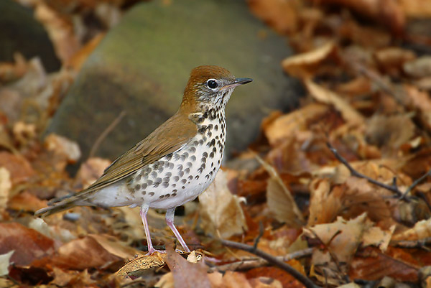Wood Thrush (Hylocichla mustelina)

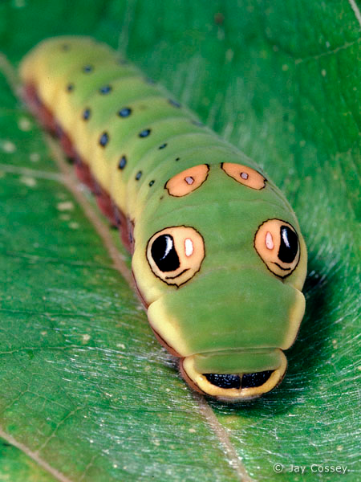 Spicebush Swallowtail Larva (Papilio troilus)

Spicebush (Lindera benzoin)

Macroscopic Carbon Cycle Diagram
With Answers
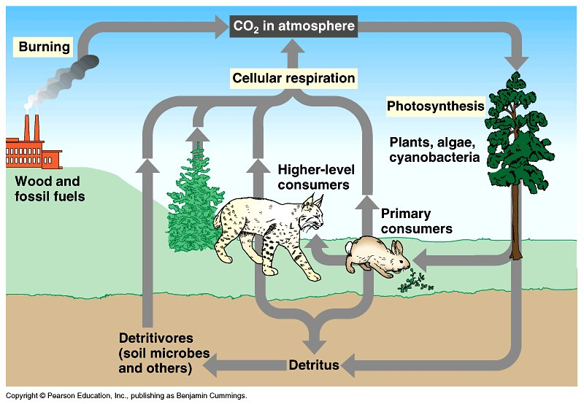
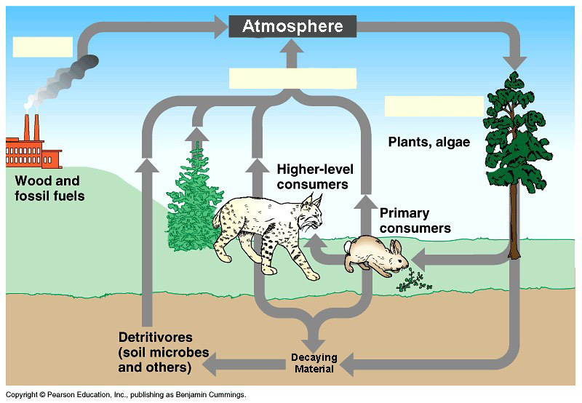

Blank

Landscape Scale Carbon Cycle Diagram
With Answers
Blank

complete carbon cycle diagram

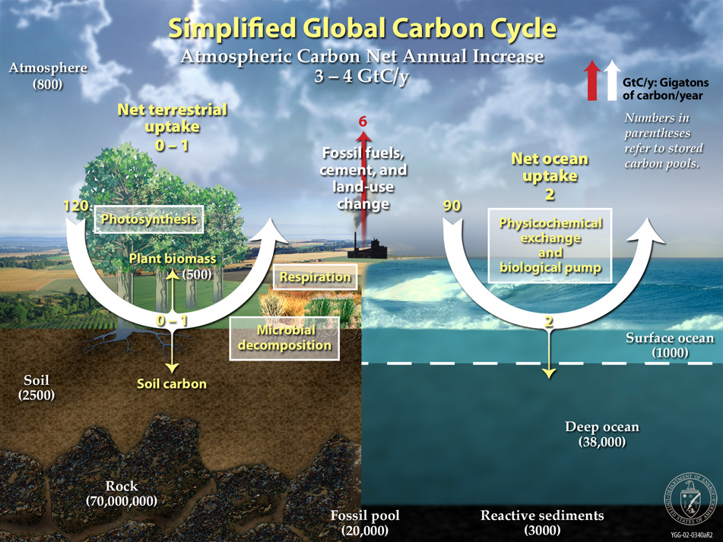
Scale

Powers of Ten
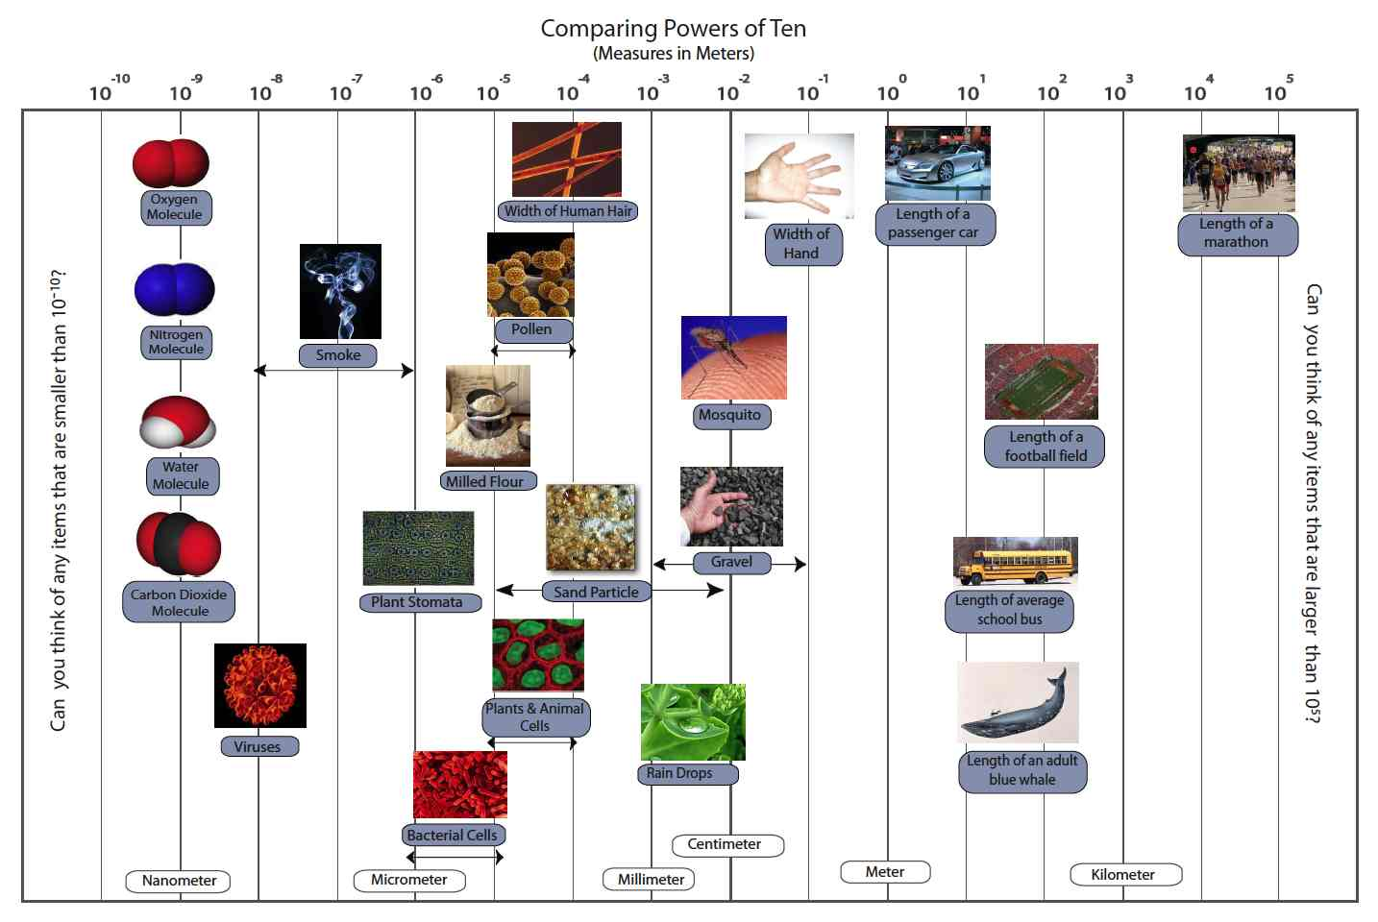

Matter and Energy

Matter and Energy Process Tool


